# REPORT SUBMISSION FORM

|  |  |  |
| --- | --- | --- |
|  | |  |
| Name: | TAN WEI LIANG | |
| Partner's Name: | AINA IMANINA BINTI MOHB KHOZIKIN | |
| Group : | M5B | |
| Experiment Code: | 1 EM 5 | |
| Experiment Title: | Alternating Current Resonance | |
|  |  | |
| Lecturer’s / Examiner’s Name: | Assoc. Prof. Dr. Lim Hwee San | |
| Starting Date (1st session): | 06/11/2023 | |
| Ending Date (2nd session): | 20/11/2023 | |
| Submission Date: | 01/12/2023 | |

# DECLARATION OF ORIGINALITY

|  |  |  |  |
| --- | --- | --- | --- |
| I, **TAN WEI LIANG** **22302889** hereby declare that this laboratory report is my own work. I further declare that:   1. The references / bibliography reflects the sources I have consulted, and 2. I also certify that this report has not previously been submitted for assessment in this or any other units, and that I have not copied in part or whole or otherwise plagiarized the work of other students and/or persons. 3. Sections with no source referrals are my own ideas, arguments and/or conclusions. | | | |
| Signature: | |  | | --- | |  | | Date: | |  | | --- | | 01/12/23 | |

|  |
| --- |
| **ALTERNATING CURRENT RESONANCE** |

|  |
| --- |
| **By** |

|  |
| --- |
| **TAN WEI LIANG** |

|  |
| --- |
| **NOVEMBER 2023** |

|  |
| --- |
| **First Year Laboratory Report** |

**ALTERNATING CURRENT RESONANCE**

# ABSTRACT

This study, titled "Alternating Current Resonance," investigates the properties of AC RLC circuits through four key objectives. The resonant frequency of a simple AC RLC series circuit was determined to be (4.50 ±0.01) kHz in the first objective. Moving to the second objective, exploration of the Q factor and resistance revealed a consistent decrease in Q factor with increasing resistance, aligning with theoretical expectations. The third objective examined the phase difference between current and applied voltage in the AC RLC series circuit. The inductor's applied voltage led the source voltage by (1.16±0.01) radians, exhibiting a 71.85% percentage discrepancy. Additionally, the capacitor's applied voltage lagged the source voltage by (1.16±0.01) radians, with a 271.85% percentage discrepancy. In the fourth objective, the resonant frequency of a parallel resonant circuit was determined to be (4.75 ±0.01) kHz. These findings enhance our understanding of AC RLC circuit behavior, offering valuable insights into resonant frequencies, Q factors, resistance effects, and phase relationships.

# Acknowledgements

First and foremost, I express my sincere appreciation to *Assoc. Prof. Dr. Lim Hwee San*, our distinguished lecturer and examiner, for the invaluable guidance and unwavering support extended throughout our scientific exploration. I extend special gratitude to *Encik Khairunizam Ahmad* our industrious lab assistant, whose meticulous time management during lab sessions and facilitation of experiment redo processes played a pivotal role in ensuring the seamless execution of our practical work. His assistance has been integral to the success of our hands-on sessions. I extend my sincere gratitude to my redo experiment partner, *Goh Zhia Wue*, and my experiment partner, *Aina Imanina Binti Mohb Khozikin*. Their invaluable cooperation and dedication throughout both experiments were instrumental to the success of this project. I appreciate their commitment, expertise, and teamwork, which made these scientific endeavors both productive and enjoyable. Additionally, I acknowledge the contributions of the original creator of this lab manual, whose identity remains unknown, yet their foundational work stands as a cornerstone to our scientific comprehension. A heartfelt acknowledgment is also extended to *Dr. John Soo Yue Han* for his dedicated efforts in revising and standardizing the manual in 2021, elevating its clarity and educational significance. This collective endeavor has significantly enhanced our scientific learning journey, and I extend genuine gratitude to everyone mentioned for their noteworthy contributions.

# CONTENTS

ABSTRACT 1

Acknowledgements 2

CONTENTS 3

LIST OF TABLES 4

LIST OF FIGURES 5

1. INTRODUCTION 6

2. THEORY 7

3. METHODOLOGY 12

4. DATA ANALYSYS 15

5. DISCUSSION AND CONCLUSION 35

6**.** REFERENCES 39

APPENDICES 40

# LIST OF TABLES

Table 1 15

Table 2 18

Table 3 21

Table 4 24

Table 5 25

Table 6 33

# LIST OF FIGURES

Figure 1. 7

Figure 2. 8

Figure 3. 9

Figure 4.10

Figure 5. 11

Figure 6.12

Figure 7. 13

Figure 8.13

Figure 9. 14

Figure 10.17

Figure 11. 17

Figure 12.20

Figure 13. 20

Figure 14.23

Figure 15. 23

Figure 16.24

Figure 17.25

Figure 18.25

Figure 19.26

Figure 20.27

Figure 21. 27

Figure 22.28

Figure 23.29

Figure 24.29

Figure 25.30

Figure 26.31

Figure 27.31

Figure 28.32

Figure 29.34

Figure 30.34

Figure 31.49

Figure 32.50

Figure 33.50

# INTRODUCTION

The purpose of this experiment is to investigate the characteristics of resonant circuits containing the three basic components in electronics, which are the resistor (𝑅), inductor (𝐿), and capacitor (𝐶). Whether simple or complicated, most circuits consist of three components.

The resistance of a pure resistor does not vary with frequency; however, inductors and capacitors possess characteristics that depend on frequency, which results in phase shifts between the applied voltage and current. When alternating current (AC) flows through a resistor, the applied voltage and current are in phase. However, the applied voltage leads the current by ¼ of a cycle (90°) for an inductor, while the current leads the applied voltage by ¼ of a cycle for a capacitor. The presence of 𝑅, 𝐿 and 𝐶 introduces an impedance within a circuit.

# 2. THEORY

**RLC Circuits**

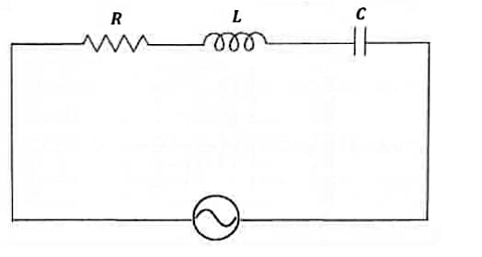

**Figure 1**: An oscillator connected to an RLC circuit in series.

Consider the RLC series circuit in **Figure 1.** When a circuit is supplied with an AC sinusoidal voltage source, the resultant current is an applied voltage as a function of frequency. Using complex notation, the impedance within a circuit is given by

𝑍 = 𝑅 + 𝑖 (${ X}_{L}$ − $X_{c}$), (1)

where 𝑅 is the resistance, XL= 2𝜋L the inductive reactance, and 𝑋𝐶 = 1/2𝜋C the capacitive reactance. Thus, the value of effective current (𝐼) is

𝐼 = $\frac{V}{Z}$ = $\frac{V}{R+({ X}_{L}- X_{c})}$*.*  (2)

The absolute value of 𝐼 can be written as

|𝐼| *=* (3) or in frequency terms,

|𝐼| =

Based on equation (4), when 𝑓 approaches zero, |𝐼| also approaches zero and vice versa. Thus, it is clear that |𝐼| possesses a maximum value at a frequency $f_{o}$, and this maximum value occurs when

$2πf_{o}L-\frac{1}{2πf_{o}C} =0$ (5).

Critical frequency $f_{o}$ can be calculated from equation (5) by the following equation.

${ f}_{o}=\frac{1}{2π\sqrt{LC}}$ (6) At this frequency, the current 𝐼 will possess a maximum value of

${|I| }_{o}$ = $\frac{|V| }{R}$ (7) whereas any other frequencies, $f$ other than ${ f}_{o}$ will result in a current, $|I|$ lower than |V|/R . Qualitatively, the frequency response is shown in **Figure 2**.

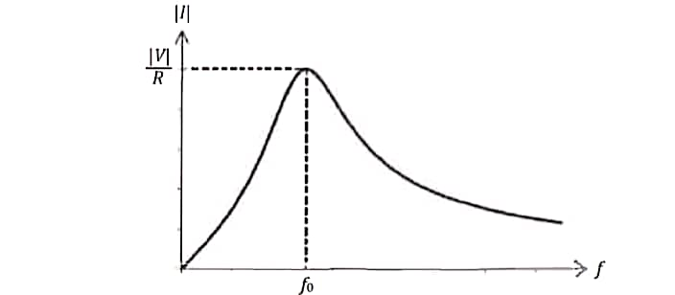

**Figure 2**: Current versus frequency in a series circuit.

Equation (2) can be used to obtain the phase angle between the applied voltage and the current using the properties of complex conjugates.

𝐼 $=\frac{V}{R+i({ X}_{L}- X_{c})}$ $\frac{R-i({ X}_{L}- X_{c})}{R-i({ X}_{L}- X_{c})}$

$=\frac{VR-iV({ X}_{L}- X_{c})}{1+({\frac{{ X}_{L}- X_{c}}{R})}^{2}}$ (8)

From this expression, it can be noticed the phase angle 𝜃 is

𝜃 = tan−1) (9) From equations (6) and (9), when 𝑓 = $f_{o}$ and *X𝐿* = *𝑋C*, then 𝜃 = tan−1(0) or 𝜃 = 0. In such case, the applied voltage and resultant current are in the same phase. This is known as the resonance condition, where the net impedance is purely resistive. It is found that at resonance, the current is maximum while the impedance is minimum.

**The Q Factor**

The Q factor describes the resonance behaviour of a resonator and can be defined as the ratio of the critical frequency to bandwidth. The bandwidth is the range of frequencies for which the oscillator resonates with power greater than half the power at the resonant frequency. The definition can be mathematically expressed as,

$$Q=\frac{f_{0}}{Δf}=\frac{2πf_{0}}{2πΔf}=\frac{ω_{0}}{Δω}$$

where $Δf$ is resonance width, $f_{0}$ is the critical frequency, $ω_{r}=2πf_{r}$.

The Q factor can also be expressed as

$$Q=\frac{ω_{0}L}{R}=\frac{1}{R}\sqrt{\frac{L}{C}}=\frac{1}{ω_{0}RC}$$

At resonance, *𝑋𝐿* = *𝑋𝐶.* Applying this assumption on equation (6) produces

$X_{L}$ = $2πf_{o}L= 2π(\frac{1}{2π\sqrt{LC}} )L$ = $\sqrt{\frac{l}{c}}=X_{o}$ (10)

Thus, it can be shown that at resonance,

2𝜋*L* = $\frac{X_{o}}{f_{o}}$, $\frac{1}{2πC }=f_{o}X_{o}$. (11)

Inserting equation (11) into equation (4) produces

|𝐼| = (12) where 𝑄 = $X_{o}$/𝑅 is known as the *Q* factor of the circuit. For practical purposes, we can rewrite equation (12) as

$\frac{|I|}{{|I|}_{o} }$ = $\frac{1}{\sqrt{1+Q^{2}{(\frac{f}{f_{o}}-\frac{f_{o}}{f})}^{2}}}$ (13)

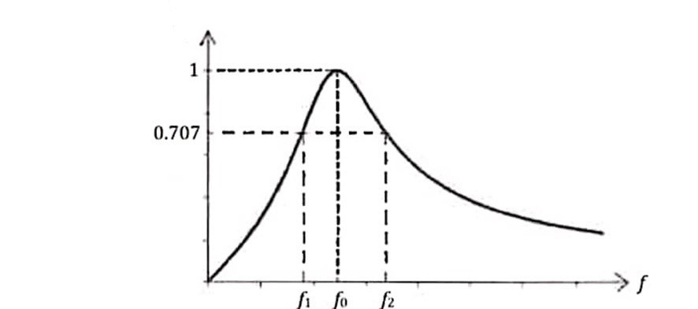

|

**Figure 3**: Graph of $|I|$/ $|I_{o}|$ versus frequency 𝑓.

The Q factor can be obtained through graphical methods, as shown in **Figure 3**. From the experiment, the Q factor can be determined from the relationship

𝑄 = $\frac{f_{o}}{f_{2}-f_{1}}$ (14) where 𝑓1 and 𝑓2 are known as half-power frequencies, when the power 𝑃 = 𝑃o/2, or when |𝐼| = |𝐼o|/ = 0.707|𝐼o|.

**Phase Measurement**

Phase measurement is the relative measurement of phase by comparing the incident signal to the response signal of a device. Phase difference is the difference in phase of two coherent points on different waveforms with the same frequency.

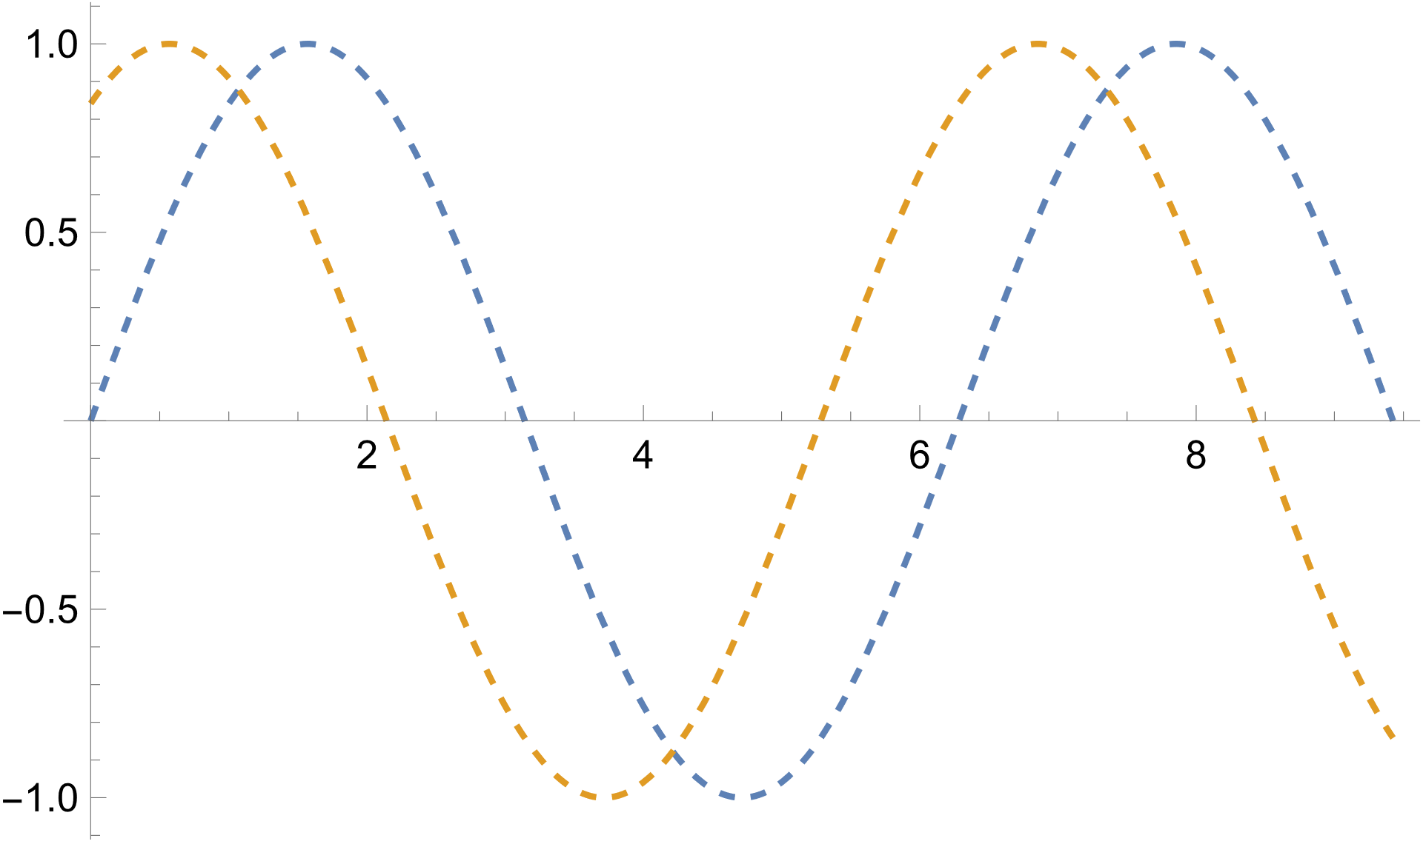

$$τ$$

T

**Figure 4:** Example of two signals with a relative phase difference $ϕ$

The phase angle $ϕ$ can be obtained by $$ϕ=360°(\frac{τ}{T})$$

where $τ$ is the difference in time between the two coherent points on different waveforms with same frequencies, and T is the period of the waves.

A common method of measuring phase difference is plotting the Lissajous figures on an oscilloscope. Lissajous figures are displayed when the X and Y axes’ inputs of the Digital Storage Oscilloscope (DSO) are sinusoidal waves. Variation is caused by three main factors: frequency, amplitude, and phase differences.

The pattern formed is sensitive to the ratio of *a/b*, where *a* is the length between the top and bottom y-intercepts and *b* is the full height of the Lissajous figure. The phase angle is determined by the following equation.

$$θ=\sin^{-1}{(±\frac{a}{b})}$$

If the *a/b*is equal to 1, the Lissajous figure forms an ellipse; if *a/b* is a rational number, the figure forms complicated, closed figures; if *a/b* is a non-rational number, the figure formed is a complicated, open figure.

**Parallel Resonant Circuits**

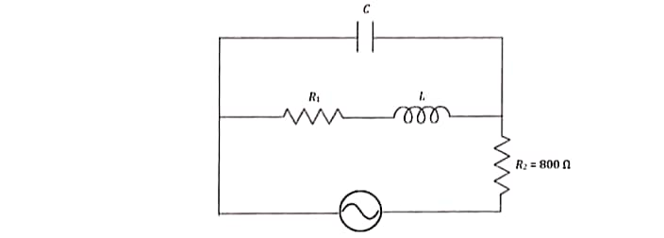

**Figure 5**: A parallel resonant circuit.

When resonance occurs in a parallel resonant circuit, the impedance is maximum but the current in the circuit becomes minimum. The resonant frequency ($f_{o}$) for a parallel circuit as shown in **Figure 5** is

# $f_{o}=\frac{1}{2π}\sqrt{\frac{1}{LC}-\frac{{R_{1}}^{2}}{L^{2}}}$ (15)

# 3. EXPERIMENTAL METHODOLOGY

**Part A: Resonant Frequency of a Series Circuit**

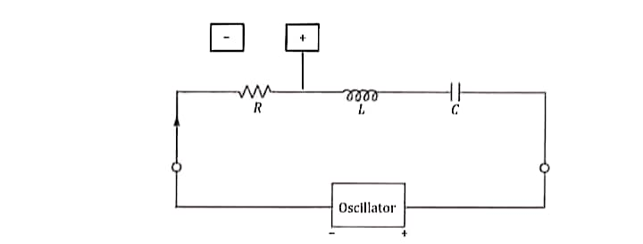

**Figure 6**: Experimental setup for Parts A and B.

The circuit was connected as shown in **Figure 6**, using resistors, inductors, and capacitors with 𝑅 = 10 kΩ, 𝐿 = 0.5 H and 𝐶 = 2100 pF, respectively. The cathode ray oscilloscope (CRO) was then connected across 𝑅 and the values of $\frac{V_{R}}{V_{R,max}}$ were then plotted against the frequency 𝑓 of the oscillator, where ${ V}_{R,max}$ is the maximum voltage across 𝑅. The resonant frequency $f_{o}$ was then determined from the plot and compared with the theoretical value.

**Part B: The Q Factor**

The circuit was connected as shown in **Figure 6** using the same values of 𝐿 and 𝐶 as in **Part A**, except R was replaced with 12 kΩ. $\frac{V_{R}}{V_{R,Max}}$ was then plotted against the corresponding frequencies 𝑓 and the value of 𝑄 was determined. The sub-experiment was repeated by replacing R with 8 kΩ. The values of 𝑄 obtained in the experiments were then compared with the theoretical values. The variation of 𝑄 with 𝑅 was then shown graphically.

**Part C: The Phase Difference between Current and Applied Voltage**

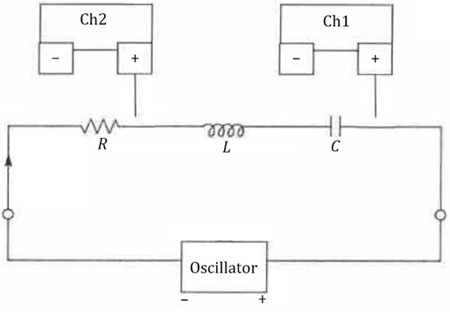

**Figure 7**: Experimental setup for Part C.

In this experiment, the circuit configuration shown in Figure 7 is utilized, with consistent values for inductance (L) and capacitance (C) as in Part A. However, the resistor (R) is replaced with an 800 Ω resistor. The first step involves connecting the circuit as per the diagram. Following the circuit setup, the next step involves employing a Cathode Ray Oscilloscope (CRO) with an oscillator frequency (f). Measurements of the voltage across the resistor (R), inductor (L), and capacitor (C) are taken using the X-plate. Subsequently, the voltage across the resistor (R) is measured using the Y-plate. Upon obtaining these measurements, a Lissajous curve is drawn, and the corresponding phase angle for the circuit is determined. The experimental phase angle is then compared with the theoretically derived value. The experiment progresses by incrementally increasing the oscillator frequency (𝑓) until it reaches its maximum (∞), and the observed behaviour at this point is discussed.



**Figure 8**: A circuit with an isolation transformer.

In the next phase of the experiment, an isolation transformer (Figure 7) is introduced to isolate the ground of the supply from that of the oscilloscope. The signal frequency is set to 3.8 kHz, and a 10 kΩ resistor (𝑅) is employed. The oscilloscope earth is connected to point 𝑄, Oscilloscope Y (Channel 2) to 𝑃, and oscilloscope X (Channel 1) to point 𝑆, positioned between the inductor (𝐿) and capacitor (𝐶). A trace is obtained and sketched. To further analysed the phase relationship between the signals, the display is set to XY, and the phase is determined from the Lissajous curve. The oscilloscope ground is then connected to 𝑃, Channel 2 to 𝑄, and Channel 1 to 𝑆. The process is repeated after interchanging the positions of the inductor (𝐿) and capacitor (𝐶). From the resulting phase angles, the experimentalist determines which component of the circuit leads and lags the signal. These findings are then compared to the theoretical expectations. The entire procedure is systematically carried out to ensure a comprehensive analysis of the alternating current resonance circuit.

**Part D: Resonant Frequency of a Parallel Circuit**

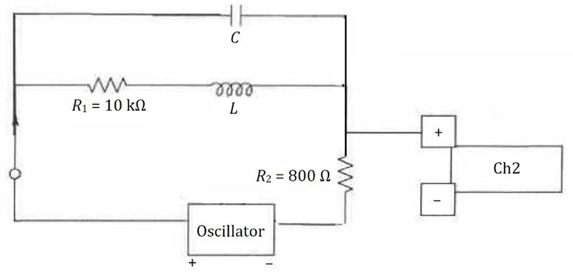

**Figure 9**: Experimental setup for Part D.

The circuit was connected as shown in **Figure 9**. The Y-plate of the CRT was connected across 𝑅2, and its voltage was measured. $V_{R_{2}}$ was plotted against the oscillator frequency. The resonant frequency, 𝑓o of the circuit was determined from graph and then compared with the theoretical value.

# 4. DATA ANALYSYS

**Part A**

When R = 10 k $Ω$, L = 0.5 H, C = 2100 pF, Vrms, max = 13.4 V, the following data set was obtained.

|  |  |  |
| --- | --- | --- |
| Frequency, ( $f±0.01)$ kHz | Vrms, (Vrms 0.01) V | Vrms/Vrms, max |
| 1.00 | 2.20 | 0.1642 |
| 1.50 | 3.40 | 0.2537 |
| 2.00 | 4.80 | 0.3582 |
| 2.50 | 6.40 | 0.4776 |
| 3.00 | 8.40 | 0.6269 |
| 3.50 | 11.00 | 0.8209 |
| 4.00 | 13.00 | 0.9701 |
| 4.50 | 13.40 | 1.0000 |
| 5.00 | 12.20 | 0.9104 |
| 5.50 | 10.40 | 0.7761 |
| 6.00 | 9.00 | 0.6716 |
| 6.50 | 7.60 | 0.5672 |
| 7.00 | 6.60 | 0.4925 |
| 7.50 | 5.80 | 0.4328 |
| 8.00 | 5.20 | 0.3881 |
| 8.50 | 4.80 | 0.3582 |
| 9.00 | 4.20 | 0.3134 |
| 9.50 | 4.00 | 0.2985 |
| 10.00 | 3.80 | 0.2836 |

**Table 1**: Data set of frequency, Vrms and normalised Vrms when R = 10 k $Ω$

From the formula for the calculation of theoretical $f_{0}$,

$=$ $\frac{1}{2π\sqrt{LC}}$ $$=\frac{1}{2π\sqrt{\left(0.5\right)\left(2100×{10}^{-12}\right)}}$$

$=$ 4911.6 Hz $=$ 4912 Hz

From the graph plotted in **Figure 11**, experimental $f_{0}$

$= 4500$ Hz

The percentage discrepancy between the theoretical and experimental values were

$$=\frac{Experimental Value – Theoretical Value}{Theoretical value} ×100\% \\ =\frac{\left|4500- 4912\right|}{4912} ×100\% \\ =8.39\%$$

∴The experimental critical frequency for a series circuit was $\left(4.50 ±0.01\right)kHz$

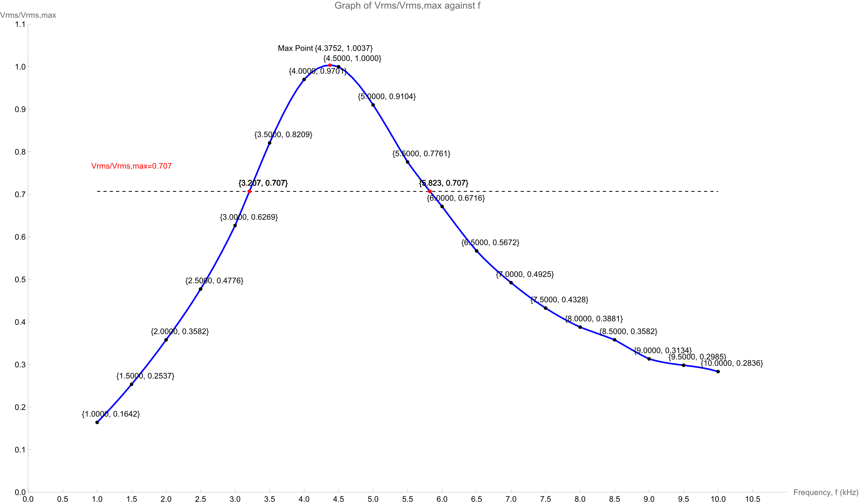

**Figure 10**: Smooth Curve Graph of Vrms/Vrms, max against frequency when R=10 k $Ω$

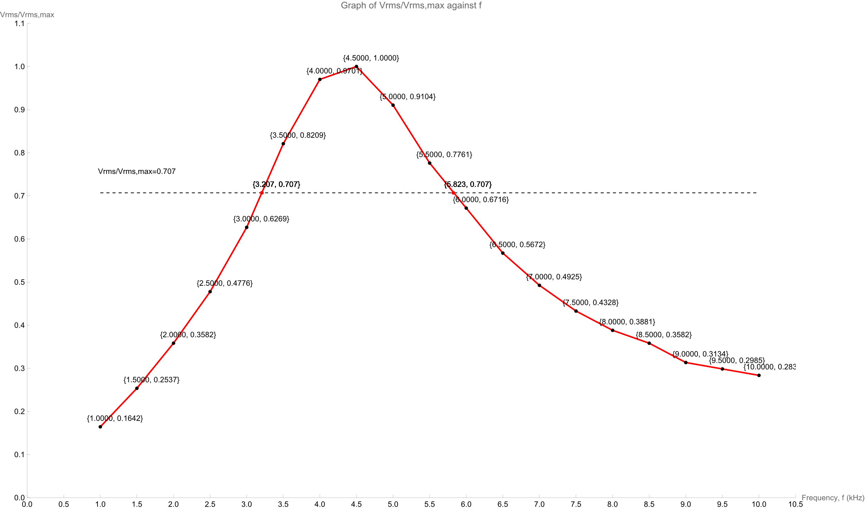**Figure 11**: Straight Line Graph of Vrms/Vrms, max against frequency when R=10 k $Ω$

In the experimental analysis, calculations using raw data reveal that when Vrms/Vrms, max=1, the experimentally determined $f_{0}= 4500$ Hz, as obtained from Figure 11. It's noteworthy that, according to theoretical expectations, $f_{0 }$ ​ should be extracted from the smooth curve in Figure 10. However, the maximum point on this curve is $f=4$.3752 $kHz$ with Vrms/Vrms, max=1.0037 >1. Therefore, the choice of $f_{0}= 4500$ Hz appears more reasonable considering the experimental results.

**Part B**

When R = 12 k $Ω$, L = 0.5 H, C = 2100 pF, Vrms, max = 4.50 V, the following data set was obtained.

|  |  |  |
| --- | --- | --- |
| Frequency, ( $f±0.01)$ kHz | Vrms, (Vrms 0.01) V | Vrms/Vrms, max |
| 1.00 | 2.60 | 0.1940 |
| 1.50 | 4.00 | 0.2985 |
| 2.00 | 5.40 | 0.4030 |
| 2.50 | 7.20 | 0.5373 |
| 3.00 | 9.40 | 0.7015 |
| 3.50 | 11.60 | 0.8657 |
| 4.00 | 13.20 | 0.9851 |
| 4.50 | 13.40 | 1.0000 |
| 5.00 | 12.60 | 0.9403 |
| 5.50 | 11.20 | 0.8358 |
| 6.00 | 9.80 | 0.7313 |
| 6.50 | 8.60 | 0.6418 |
| 7.00 | 7.60 | 0.5672 |
| 7.50 | 6.80 | 0.5075 |
| 8.00 | 6.20 | 0.4627 |
| 8.50 | 5.40 | 0.4030 |
| 9.00 | 5.00 | 0.3731 |
| 9.50 | 4.60 | 0.3433 |
| 10.00 | 4.20 | 0.3134 |

**Table 2**: Data set of frequency, Vrms and normalised Vrms when R = 12 k $Ω$

Using the formula for calculation of Q from resistance, reactance of both inductor and capacitor, the theoretical value of Q when R = 10 k $Ω$ was

$$Q=\frac{X_{o}}{R}=\frac{1}{R}∙\sqrt{\frac{L}{C}} \\ =\frac{1}{12000}∙\sqrt{\frac{0.5}{2100×{10}^{-12}}} \\ =1.286$$

From **Figure 13** experimental value of Q when R = 12 k was

𝑄 = , f0= 4.500 kHz, f1= 3.016 kHz, f2=6.128 kHz $$=\frac{4.500}{6.128-3.016}$$  $=$ 1.446

The percentage discrepancy between the theoretical and experimental values Q when R = 12 k $Ω$ were

$$=\frac{Experimental Value – Theoretical Value}{Theoretical value} ×100\% \\ =\frac{\left|1.446- 1.286\right|}{1.286} ×100\% \\ =12.44 \%$$

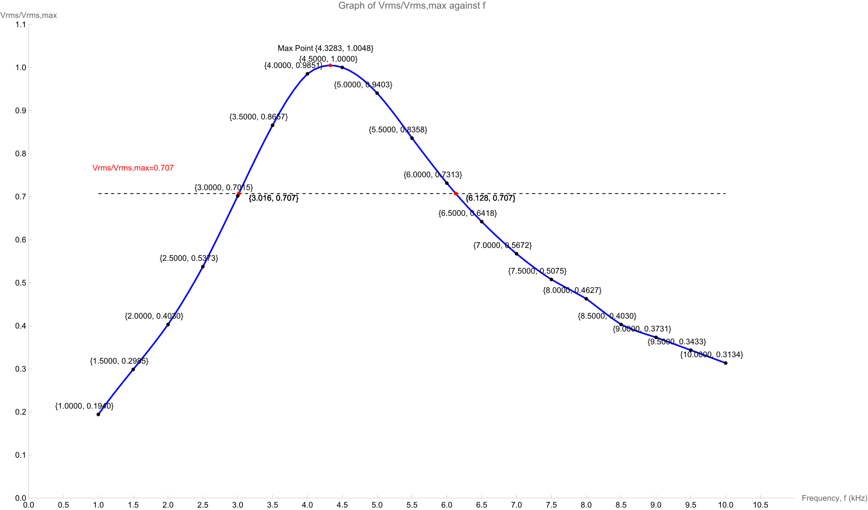

**Figure 12**: Smooth Curve Graph of Vrms/Vrms, max against frequency when R=12 k $Ω$

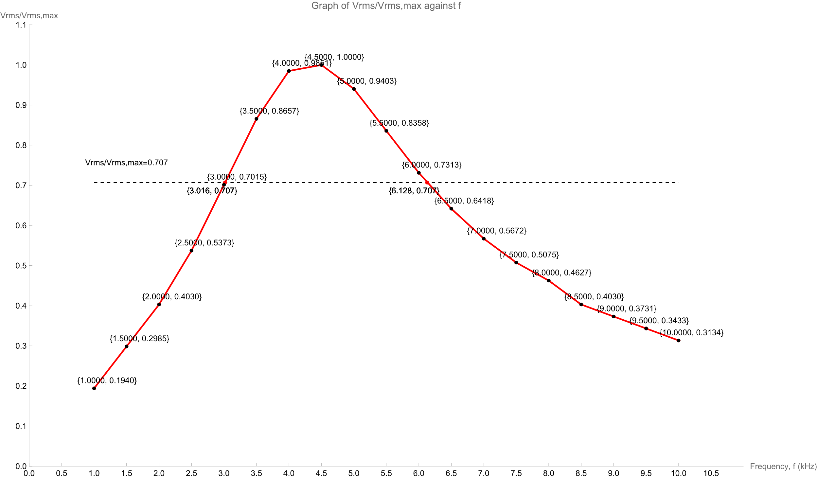

**Figure 13**: Straight Line Graph of Vrms/Vrms, max against frequency when R=12 k $Ω$

In the experimental analysis, calculations using raw data reveal that when Vrms/Vrms, max=1, the experimentally determined $f_{0}= 4500$ Hz, as obtained from Figure 13. It's noteworthy that, according to theoretical expectations, $f_{0 }$ ​ should be extracted from the smooth curve in Figure 12. However, the maximum point on this curve is $f=4$.3283 $kHz$ with Vrms/Vrms, max=1.0048 >1. Therefore, the choice of $f_{0}= 4500$ Hz appears more reasonable considering the experimental results.

When R = 8 k $Ω$, L = 0.5 H, C = 2100 pF, Vrms, max = 4.50 V, the following data set was obtained.

|  |  |  |
| --- | --- | --- |
| Frequency, ( $f±0.01)$ kHz | Vrms, (Vrms 0.01) V | Vrms/Vrms, max |
| 1.00 | 1.80 | 0.1343 |
| 1.50 | 2.80 | 0.2090 |
| 2.00 | 4.00 | 0.2985 |
| 2.50 | 5.20 | 0.3881 |
| 3.00 | 7.40 | 0.5522 |
| 3.50 | 10.20 | 0.7612 |
| 4.00 | 12.80 | 0.9552 |
| 4.50 | 13.40 | 1.0000 |
| 5.00 | 11.40 | 0.8507 |
| 5.50 | 9.40 | 0.7015 |
| 6.00 | 7.80 | 0.5821 |
| 6.50 | 6.60 | 0.4925 |
| 7.00 | 5.40 | 0.4030 |
| 7.50 | 5.00 | 0.3731 |
| 8.00 | 4.40 | 0.3284 |
| 8.50 | 4.20 | 0.3134 |
| 9.00 | 4.00 | 0.2985 |
| 9.50 | 3.40 | 0.2537 |
| 10.00 | 3.00 | 0.2239 |

**Table 3**: Data set of frequency, Vrms and normalised Vrms when R = 8 k $Ω$

Using the formula for calculation of Q from resistance, reactance of both inductor and capacitor, the theoretical value of Q when R = 10 k $Ω$ was

$$Q=\frac{X_{o}}{R}=\frac{1}{R}∙\sqrt{\frac{L}{C}} \\ =\frac{1}{8000}∙\sqrt{\frac{0.5}{2100×{10}^{-12}}} \\ =1.929$$

From **Figure 15** experimental value of Q when R = 8 k was

𝑄 = , f0= 4.500 kHz, f1=3.373 kHz, f2=5.480 kHz $$=\frac{4.500}{5.480-3.373}$$  $=$ 2.136

The percentage discrepancy between the theoretical and experimental values Q when R = 8 k $Ω$ were

$$=\frac{Experimental Value – Theoretical Value}{Theoretical value} ×100\% \\ =\frac{\left|2.136- 1.929\right|}{1.929} ×100\% \\ =10.73 \%$$

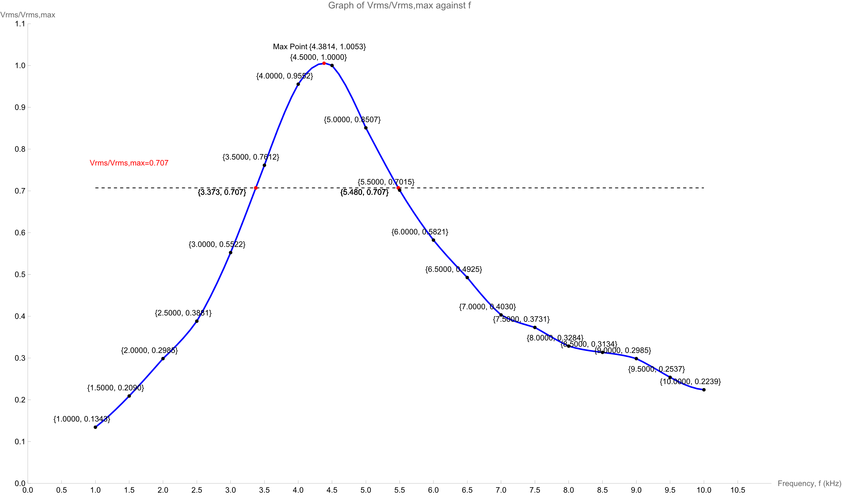

**Figure 14**: Smooth Curve Graph of Vrms/Vrms, max against frequency when R=8 k $Ω$

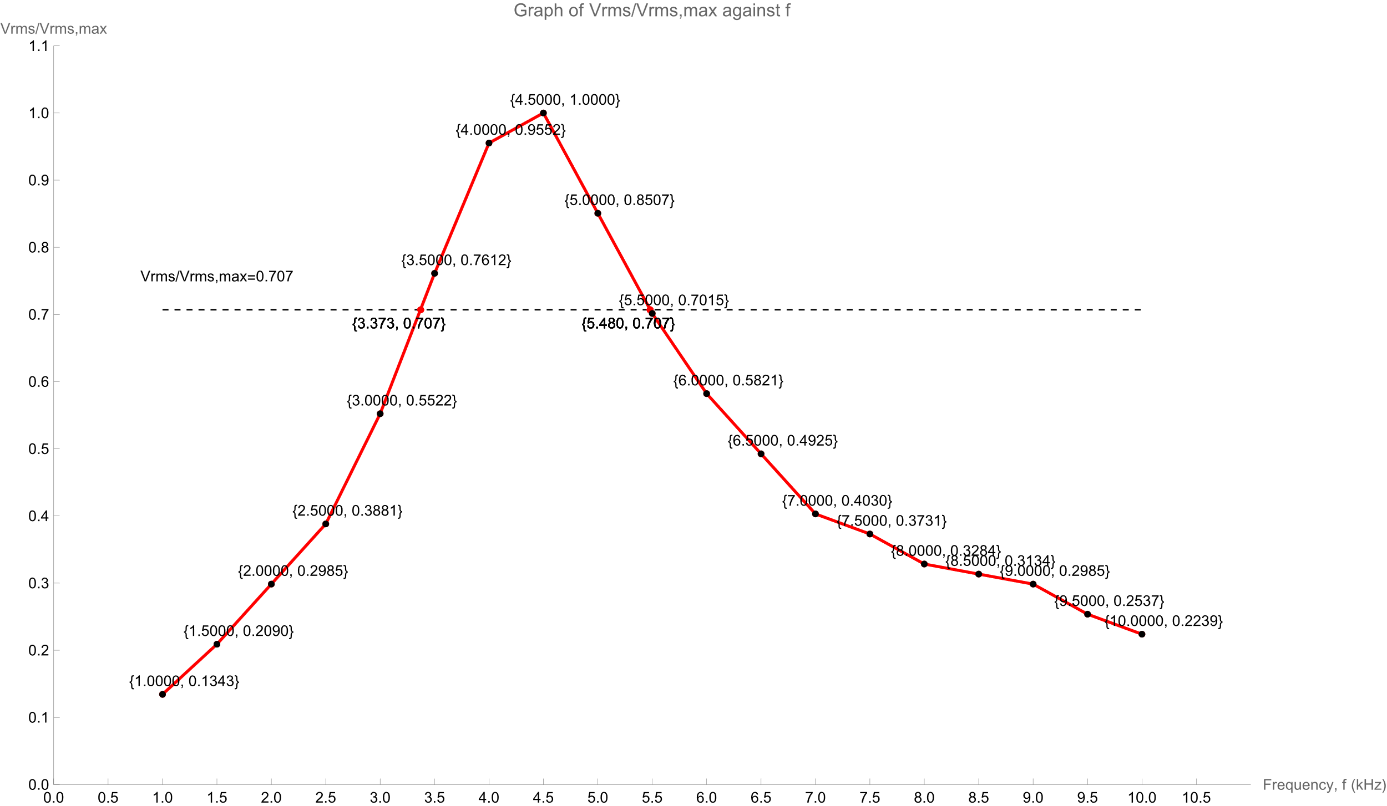

**Figure 15**: Straight Line Graph of Vrms/Vrms, max against frequency when R=8 k $Ω$

In the experimental analysis, calculations using raw data reveal that when Vrms/Vrms, max=1, the experimentally determined $f_{0}= 4500$ Hz, as obtained from Figure 15. It's noteworthy that, according to theoretical expectations, $f_{0 }$ ​ should be extracted from the smooth curve in Figure 14. However, the maximum point on this curve is $f=4$.3814 $kHz$ with Vrms/Vrms, max=1.0053 >1. Therefore, the choice of $f_{0}= 4500$ Hz appears more reasonable considering the experimental results.

|  |  |  |
| --- | --- | --- |
| Resistance, R (k $Ω$) | Experimental Q | Theoretical Q |
| 8 | 2.136 | 1.929 |
| 12 | 1.446 | 1.286 |

**Table 4**: Data set of resistance, experimental and theoretical Q

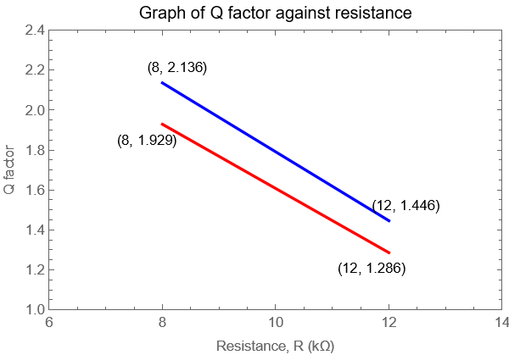

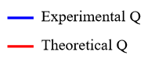

**Figure 16**: Graph of Q factor (Experimental & Theoretical) against resistance

Experimental Equation: Q = -0.17250 R + 3.520

Theoretical Equation: Q = -0.16075 R + 3.210

**Part C**

|  |  |  |
| --- | --- | --- |
| Connection | Theoretical Value, 𝜃(rad.) | ExperimentalValue,𝜃(rad.) |
| First | -0.675 | -1.160 |
| Second | -0.675 | -0.340 |
| Third | -0.675 | +1.160 |
| Forth | -0.675 | +1.160 |

**Table 5**: Results for part C

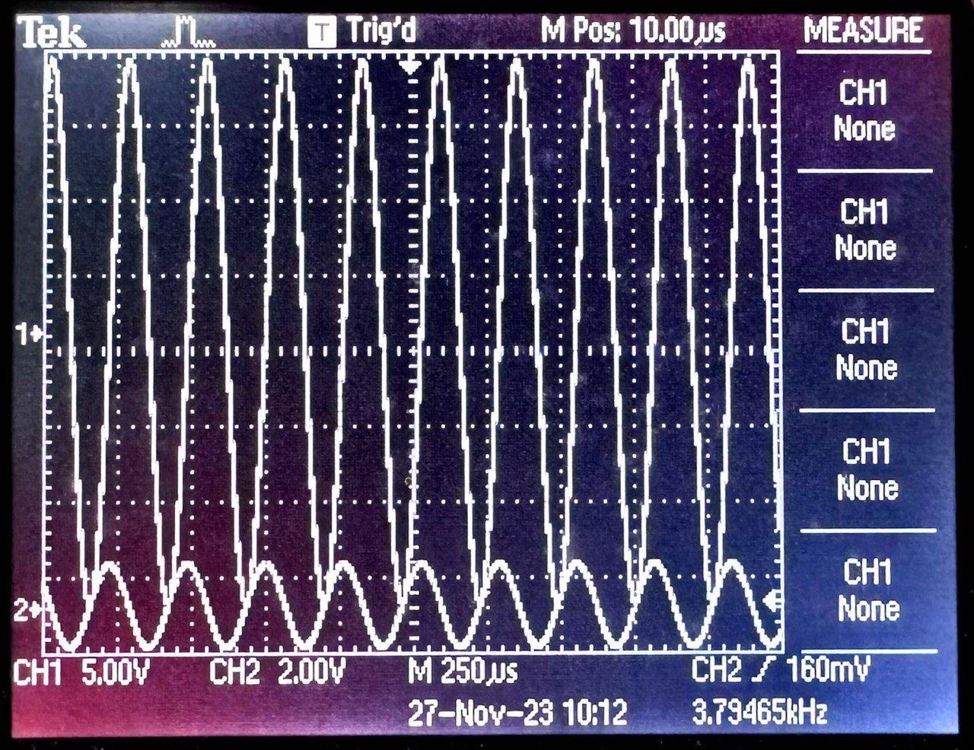

**Figure 17**: Graph of phase difference when Channel 2 is connected to site P, ground to site Q, Channel 1 to site S.

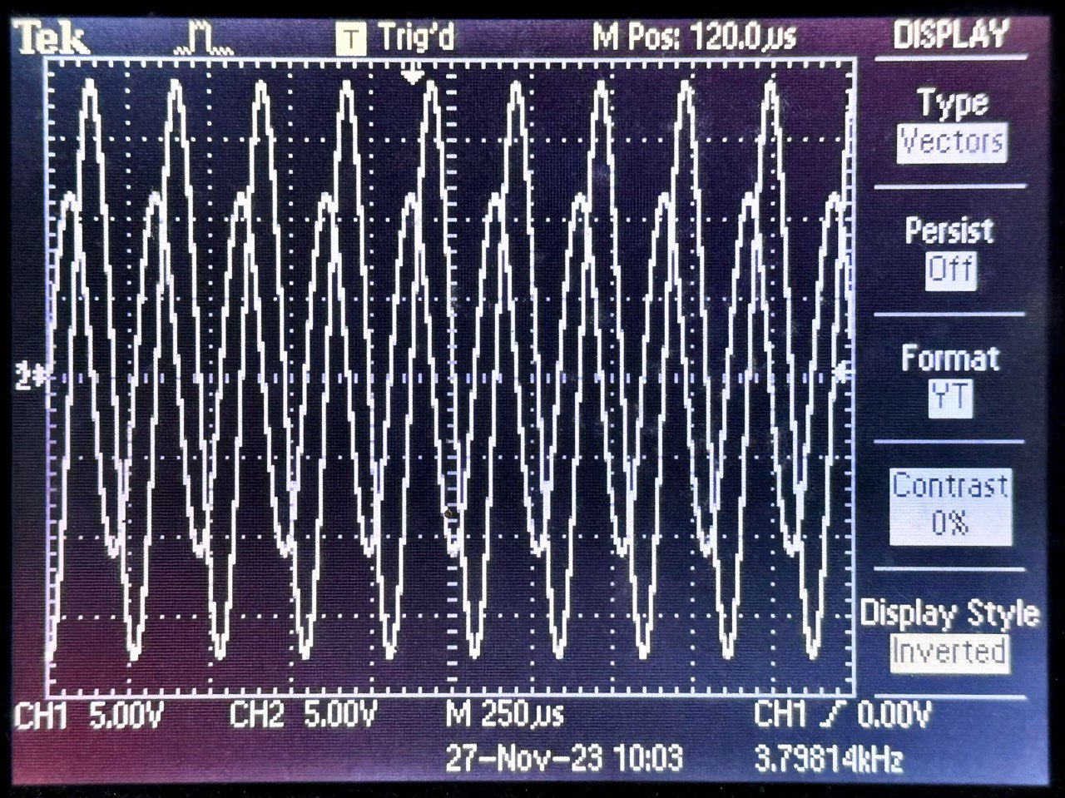

**Figure 18**: Graph of phase difference (overlap) when Channel 2 is connected to site P, ground to site Q, Channel 1 to site S.

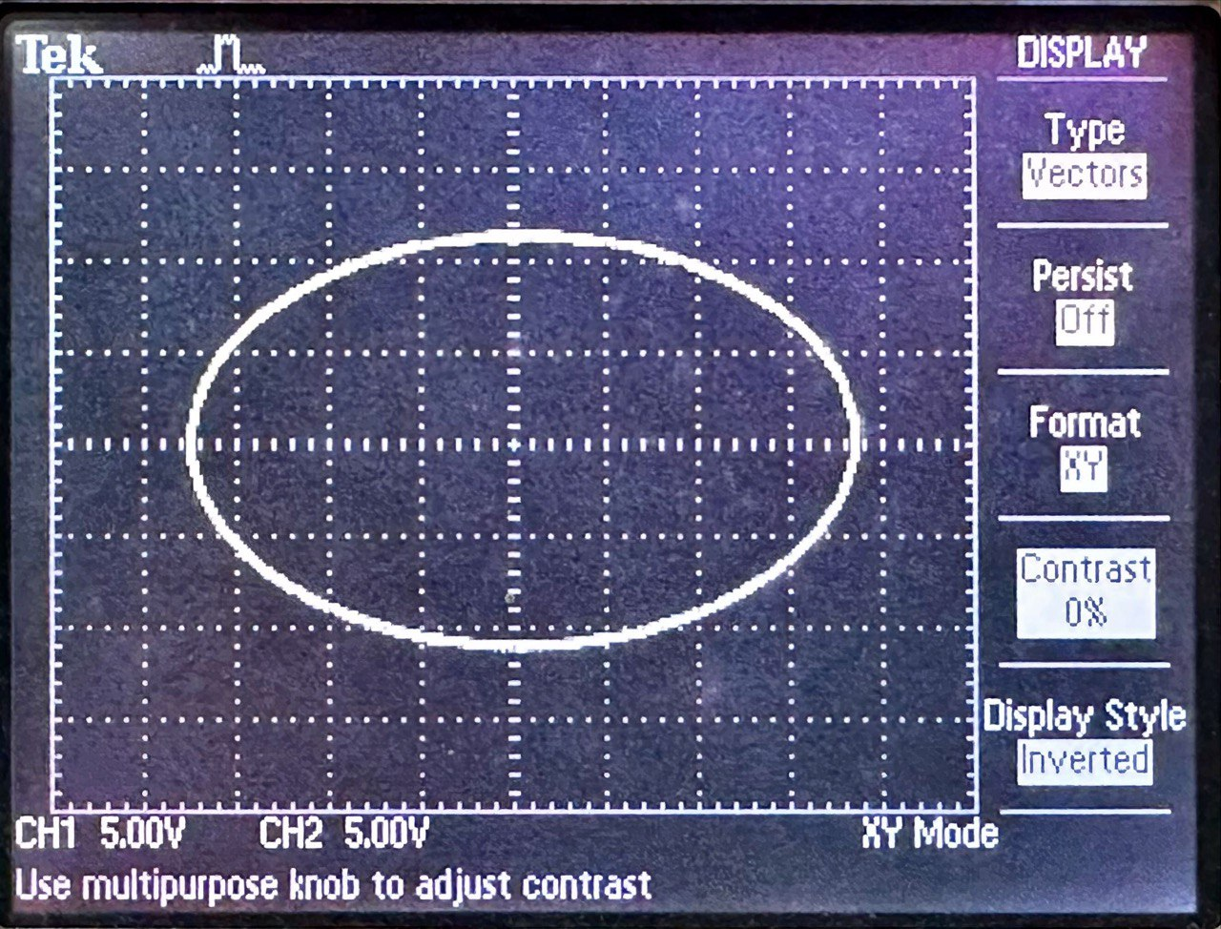

**Figure 19**: Graph of Lissajous figure when Channel 2 is connected to site P, ground to site Q, Channel 1 to site S.

Inductor reactance, $X_{L}=2πf_{o}L=2π\left(3800\right)\left(0.5\right)=11938 H s^{-1}$ Capacitor reactance, $X_{c}=\frac{1}{2πf_{o}C}=\frac{1}{2π(3800)(2100×{10}^{-12})}=19944 s F$

From calculations, theoretical phase angle was  
𝜃 = tan−1 rad

From **Figure 19** experimental phase angle was

A =24 V

B =22 V

$θ=\sin^{-1}{(±\frac{B}{A})}=\sin^{-1}\left(±\frac{22}{24}\right)=$-1.160 rad

The positive values were rejected since the curve is rotated anti-clockwise from the y-axis.

The percentage discrepancy between the theoretical and experimental values were

$$=|\frac{Experimental Value – Theoretical Value}{Theoretical value}| ×100\% \\ =|\frac{-1.160-(-0.675) }{-0.675}| ×100\% \\ =71.85 \%$$

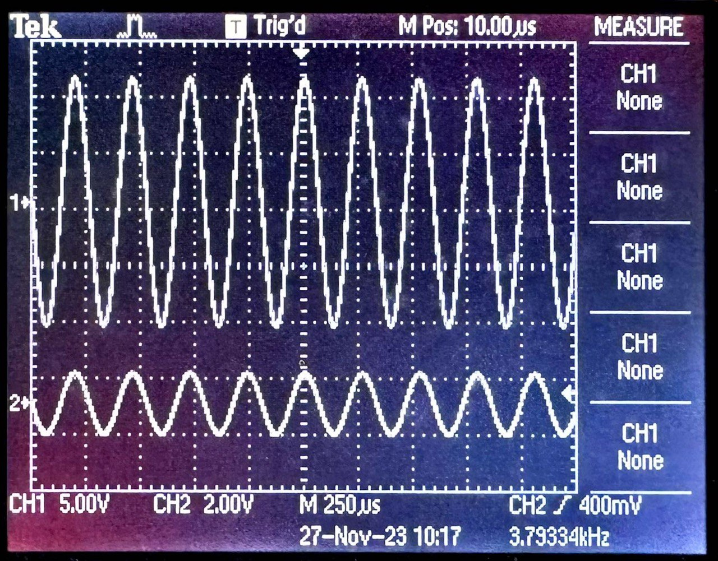

**Figure 20**: Graph of phase difference when Channel 2 is connected to site Q, ground to site P, Channel 1 to site S.

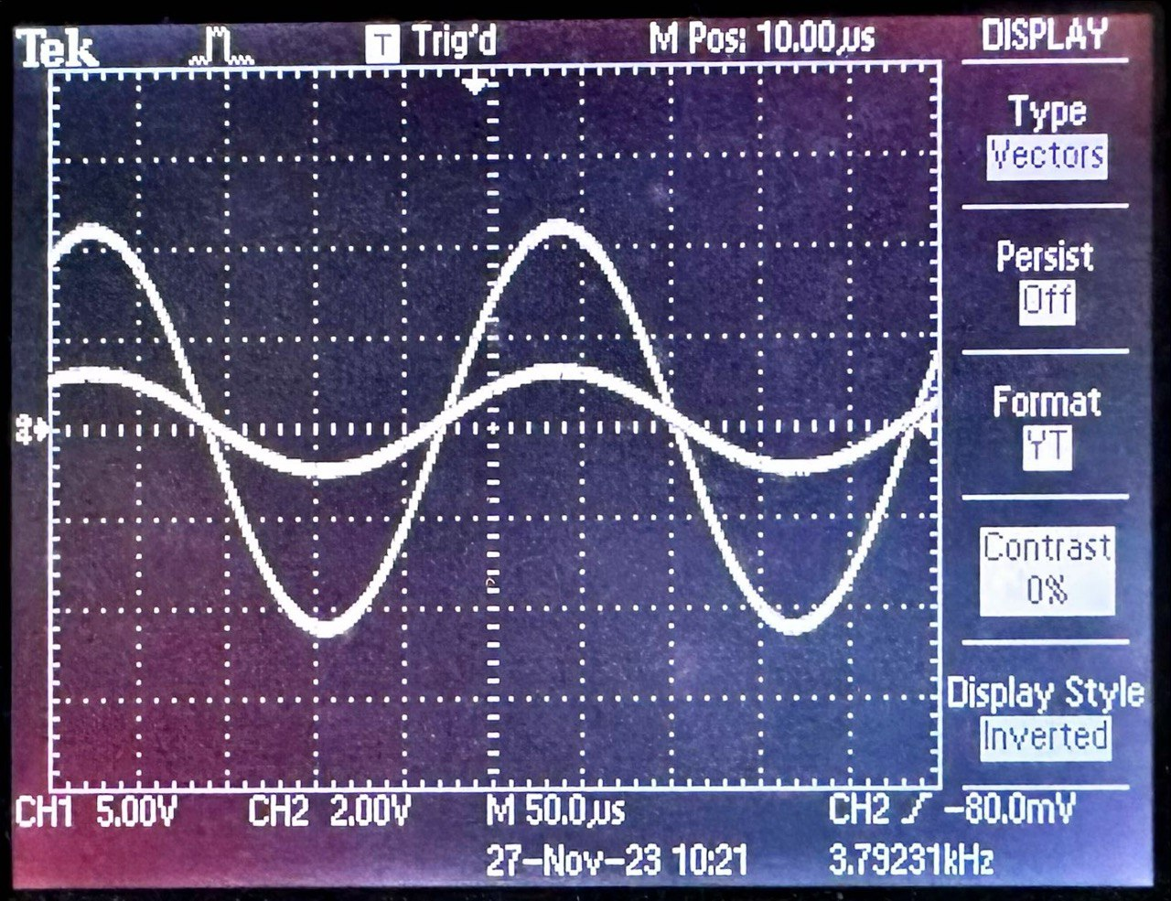

**Figure 21**: Graph of phase difference (overlap) when Channel 2 is connected to site Q, ground to site P, Channel 1 to site S.

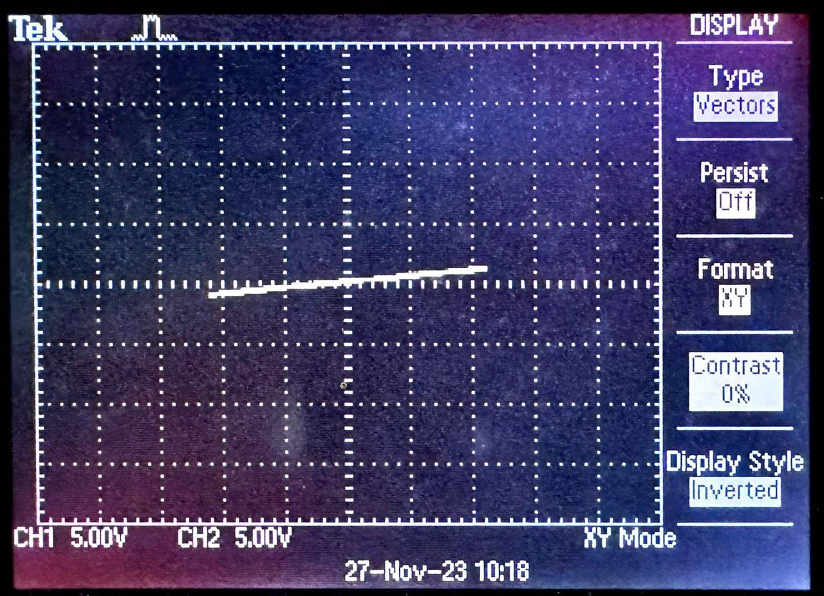

**Figure 22**: Graph of Lissajous figure when Channel 2 is connected to site Q, ground to site P, Channel 1 to site S.

Inductor reactance, $X_{L}=2πf_{o}L=2π\left(3800\right)\left(0.5\right)=11938 H s^{-1}$ Capacitor reactance, $X_{c}=\frac{1}{2πf_{o}C}=\frac{1}{2π(3800)(2100×{10}^{-12})}=19944 s F$

From calculations, theoretical phase angle was  
𝜃 = tan−1 rad

From **Figure 22** experimental phase angle was

A = 3 V

B = 1 V

$θ=\sin^{-1}{(±\frac{B}{A})}=\sin^{-1}\left(±\frac{1}{3}\right)=$-0.340 rad

The positive values were rejected since the curve is rotated anti-clockwise from the y-axis.

The percentage discrepancy between the theoretical and experimental values were

$$=|\frac{Experimental Value – Theoretical Value}{Theoretical value}| ×100\% \\ =|\frac{-0.340 - (-0.675) }{-0.675}|×100\% \\ =49.63 \%$$

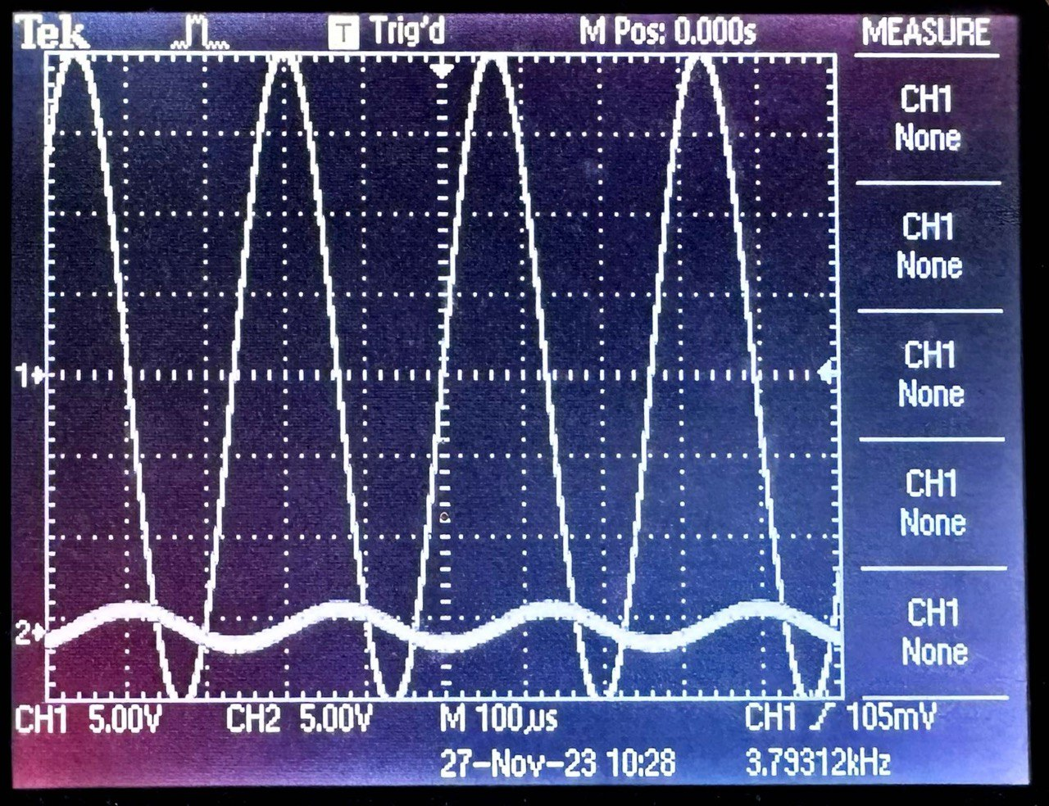

**Figure 23**: Graph of phase difference when interchange L and C, Channel 2 is connected to site P, ground to site Q, Channel 1 to site S.

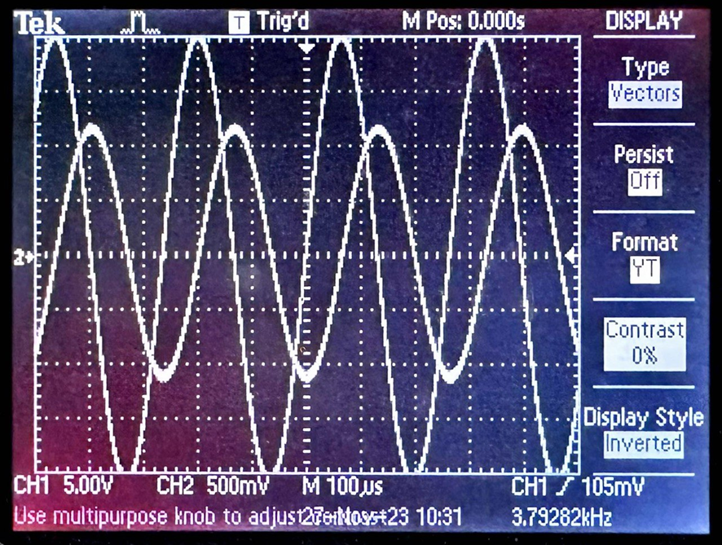

**Figure 24**: Graph of phase difference when interchange L and C, Channel 2 is connected to site P, ground to site Q, Channel 1 to site S.

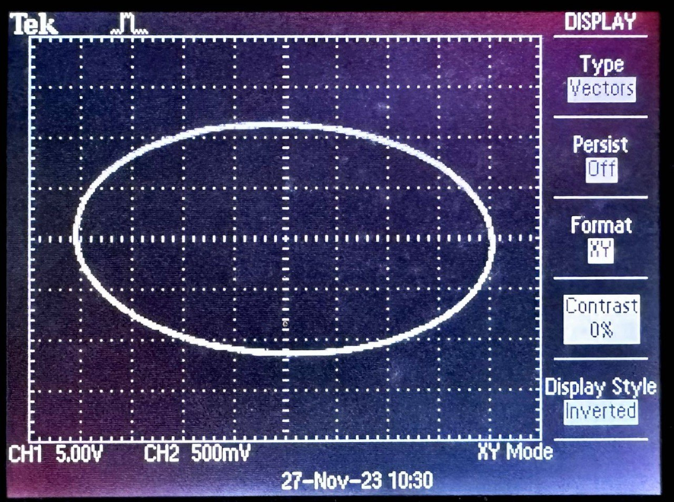

**Figure 25**: Graph of Lissajous figure when interchange L and C, Channel 2 is connected to site P, ground to site Q, Channel 1 to site S.

Inductor reactance, $X_{L}=2πf_{o}L=2π\left(3800\right)\left(0.5\right)=11938 H s^{-1}$ Capacitor reactance, $X_{c}=\frac{1}{2πf_{o}C}=\frac{1}{2π(3800)(2100×{10}^{-12})}=19944 s F$

From calculations, theoretical phase angle was  
𝜃 = tan−1 rad

From **Figure 25** experimental phase angle was

A = 24 V

B = 22 V

$θ=\sin^{-1}{(±\frac{B}{A})}=\sin^{-1}\left(±\frac{22}{24}\right)=+1.160$ rad

The negative values were rejected since the curve is rotated anti-clockwise from the y-axis.

The percentage discrepancy between the theoretical and experimental values were

$$=|\frac{Experimental Value – Theoretical Value}{Theoretical value}| ×100\% \\ =|\frac{1.160-(-0.675) }{-0.675}| ×100\% \\ =271.85 \%$$

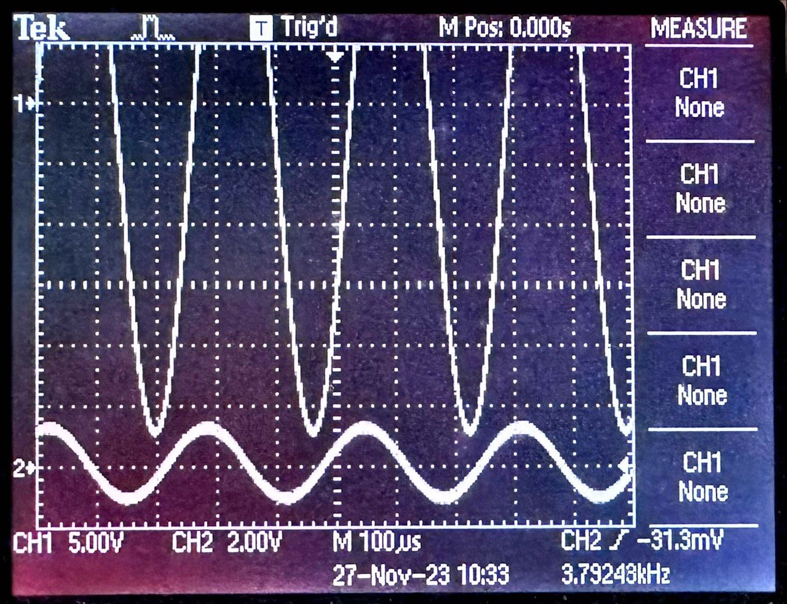

**Figure 26**: Graph of phase difference when interchange L and C, Channel 2 is connected to site Q, ground to site P, Channel 1 to site S.

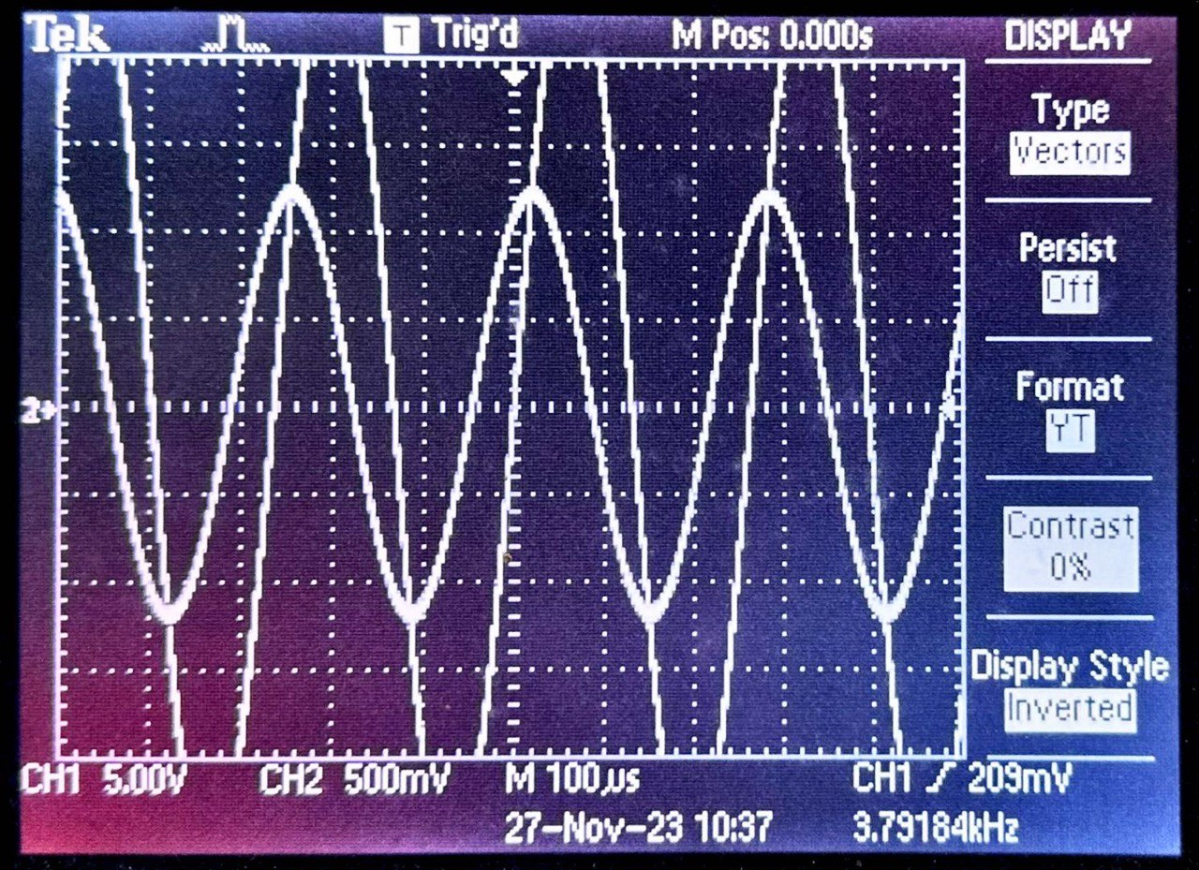

**Figure 27**: Graph of phase difference when interchange L and C, Channel 2 is connected to site Q, ground to site P, Channel 1 to site S.

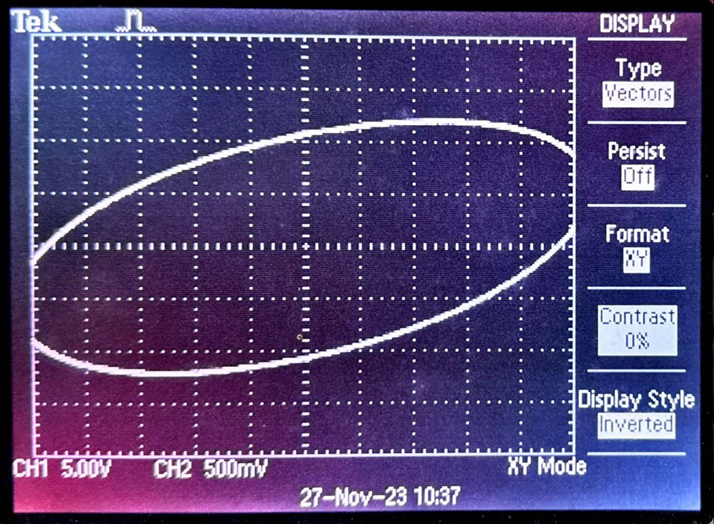

**Figure 28**: Graph of Lissajous figure when interchange L and C , Channel 2 is connected to site Q, ground to site P, Channel 1 to site S.

Inductor reactance, $X_{L}=2πf_{o}L=2π\left(3800\right)\left(0.5\right)=11938 H s^{-1}$ Capacitor reactance, $X_{c}=\frac{1}{2πf_{o}C}=\frac{1}{2π(3800)(2100×{10}^{-12})}=19944 s F$

From calculations, theoretical phase angle was  
𝜃 = tan−1 rad

From **Figure 28** experimental phase angle was

A = 24 V

B = 22 V

$θ=\sin^{-1}{(±\frac{B}{A})}=\sin^{-1}\left(±\frac{22}{24}\right)=+1.160$ rad

The negative values were rejected since the curve is rotated anti-clockwise from the y-axis.

The percentage discrepancy between the theoretical and experimental values were

$$=\frac{Experimental Value – Theoretical Value}{Theoretical value} ×100\% \\ =|\frac{1.160-(-0.675)}{-0.675}| ×100\% \\ =271.85 \%$$

**Part D**

When $R_{1}=$ 10 k $Ω$, $R_{2}=$ 0.80 k $Ω,$ L = 0.5 H, C = 2100 pF, Vrms,min = 0.48 V, the following data set was obtained.

|  |  |  |
| --- | --- | --- |
| Frequency, ( $f±0.01)$ kHz | Vrms, (Vrms 0.01) V | Vrms/Vrms, min |
| 1.00 | 0.96 | 2.0000 |
| 1.50 | 0.92 | 1.9167 |
| 2.00 | 0.80 | 1.6667 |
| 2.50 | 0.72 | 1.5000 |
| 3.00 | 0.60 | 1.2500 |
| 3.50 | 0.64 | 1.3333 |
| 4.00 | 0.56 | 1.1667 |
| 4.50 | 0.48 | 1.0000 |
| 5.00 | 0.48 | 1.0000 |
| 5.50 | 0.56 | 1.1667 |
| 6.00 | 0.80 | 1.6667 |
| 6.50 | 0.84 | 1.7500 |
| 7.00 | 0.88 | 1.8333 |
| 7.50 | 0.96 | 2.0000 |
| 8.00 | 1.12 | 2.3333 |
| 8.50 | 1.20 | 2.5000 |
| 9.00 | 1.26 | 2.6250 |
| 9.50 | 1.28 | 2.6667 |
| 10.00 | 1.44 | 3.0000 |

**Table 6**: Data set of frequency, Vrms and normalised Vrms when R = 10 k $Ω$

From the formula for the calculation of theoretical $f_{0}$,

$=\frac{1}{2π}\sqrt{\frac{1}{LC}-\frac{{R_{1}}^{2}}{L^{2}}}$, R=10 $kΩ$, L = 0.5H, C = 2100 pF

$$=\frac{1}{2π}\sqrt{\frac{1}{\left(0.5\right)\left(2100×{10}^{-12}\right)}-\frac{{\left(10000\right)}^{2}}{{\left(0.5\right)}^{2}}} \\ =3741 Hz$$

From the graph plotted in **Figure 23**, experimental $f_{0}$

$= 4750$ Hz

The percentage discrepancy between the theoretical and experimental values were

$$=\frac{Experimental Value – Theoretical Value}{Theoretical value} ×100\% \\ =\frac{\left|4750- 3741\right|}{3741} ×100\% \\ =26.97\%$$

∴The experimental critical frequency for a series circuit was $\left(4.75 ±0.01\right)kHz$

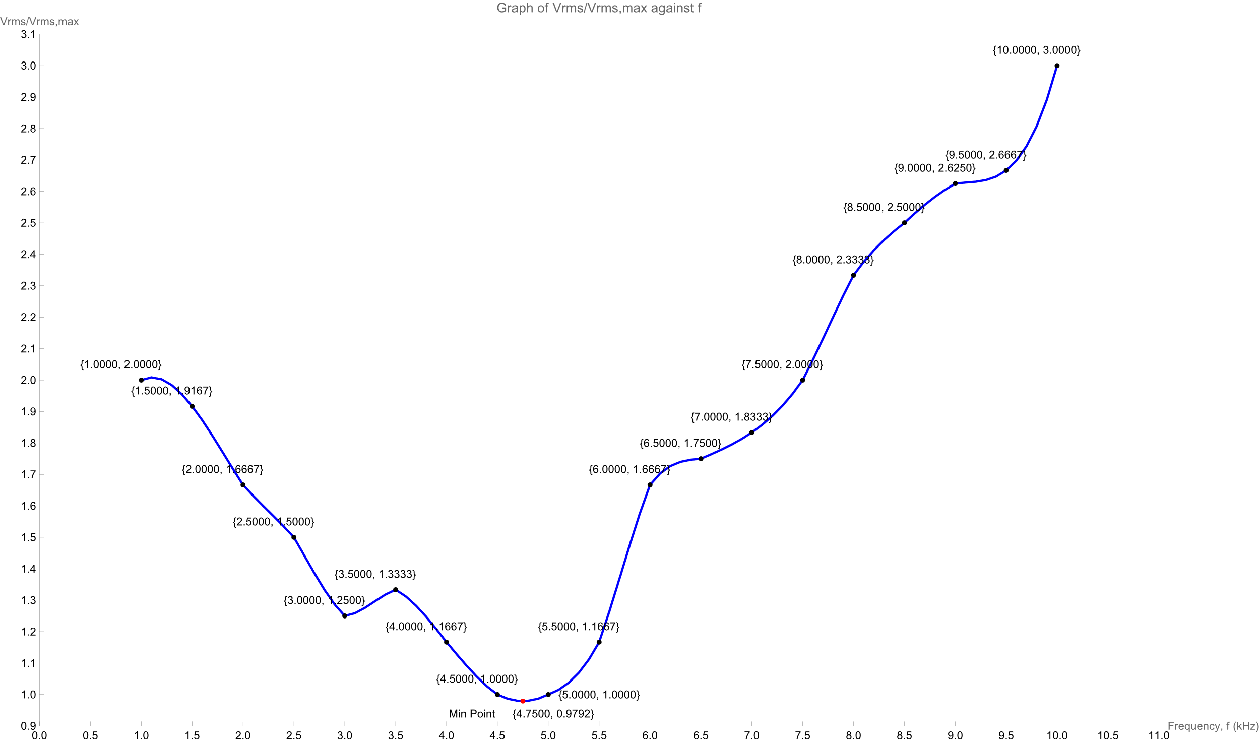

**Figure 29**: Smooth Curve Graph of Vrms/Vrms, min against frequency for parallel circuit

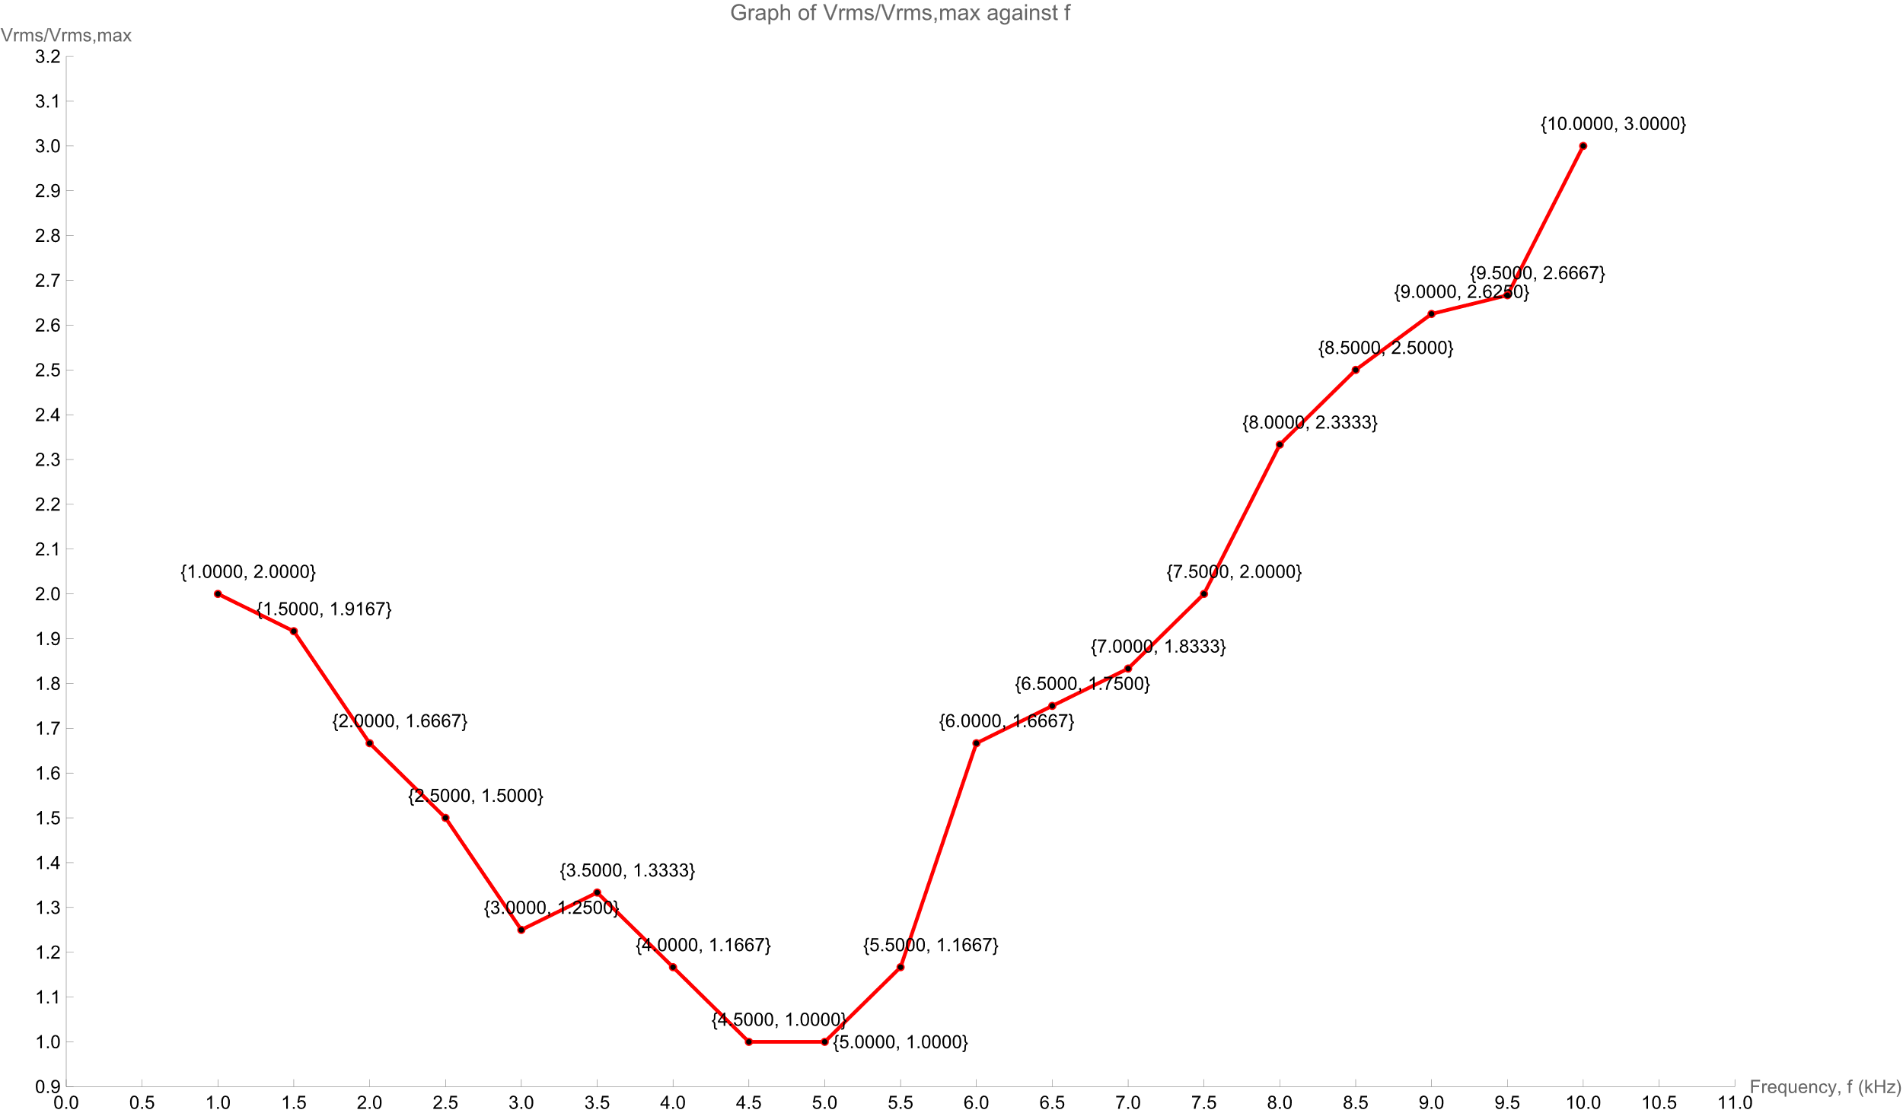

**Figure 30**: Straight Line Graph of Vrms/Vrms, min against frequency for parallel circuit

In the experimental analysis, calculations using raw data reveal that when Vrms/Vrms, min=1, the experimentally determined $f_{0}= 4500$ Hz, as obtained from Figure 24. It's noteworthy that, according to theoretical expectations, $f_{0 }$ ​ should be extracted from the smooth curve in Figure 23. However, the minimum point on this curve is $f=4$.7500 $kHz$ with Vrms/Vrms, min=0.9792<1. Interestingly, $f=4$.7500 $kHz$ falls between the points $f=4$.5000 $kHz$ and $f=5.0$ 000 $kHz$, both with Vrms/Vrms, min=1. Consequently, the selection of $f_{0}= 4750$ Hz appears more reasonable considering the experimental results.

# 5. DISCUSSION AND CONCLUSION

**DISCUSSION**

For experiment Part A, a noteworthy disparity between the experimentally obtained critical frequency (4.50 ± 0.01) kHz and the theoretical value (4.91 ± 0.01) kHz was observed. The 412 Hz difference, coupled with an 8.39% percentage discrepancy, indicates a significant deviation. This discrepancy is particularly notable as the lower limit of the experimental value does not encompass the upper limit of the theoretical value, emphasizing the need for further investigation.

From the graphical representation in Figure 10, the Vrms/Vrms, max increases to a maximum value of 1.0 around 4.50 kHz, before decreasing exponentially and flattening is explained by the gradual reduction in the difference between the reactance of the inductor and capacitor. At maximum, the reactance from the inductor and capacitor cancels out each other, resulting in a circuit dominated solely by resistance, consistent with theoretical expectations. Subsequently, the impedance increases as the inductive reactance increment surpasses the decrease in capacitive reactance.

To address the substantial experimental-theoretical data mismatch, a suggestion is made to collect a more extensive dataset to mitigate outliers and enhance data distribution.

For experiment Part B, the theory states that the Q factor is related to resistance by the equation:

$$Q=\frac{ω_{0}L}{R}$$

This means if resistance increases, Q factor decreases. experimentally, higher Q factors 2.136 and 1.446 were observed for resistances of 8 kΩ and 12 kΩ, respectively, compared to theoretical values 1.929 and 1.286. This discrepancy is attributed to practical limitations, such as resistance from other sources and signal generation fluctuations. Despite the discrepancy, the trends observed in Figure 16 indicate an agreement between experimental and theoretical values.

Based on Figure 16, the experimental and theoretical values exhibit the same trend, indicating an agreement between the experiment and theory. The theoretical data also shows the same downward trend, which indicates the experiment was conducted properly.

For experiment Part C, when Channel 2 is connected to site P, ground to site Q, Channel 1 to site S. the theoretical phase angle for the series arranged in the order Resistance-Inductor-Capacitor is -0.675 radians whereas the angle for the series arranged in the order Resistance-Capacitor-inductor is 0.675 radians. The experimental value of the phase angle for the series arranged in the order Resistance-Inductor-Capacitor is $-(1.16±0.01)$ radians whereas the phase angle for the series arranged in the order Resistance-Capacitor-inductor is $+(1.16±0.01)$ radians. There is significant discrepancy as the percentage discrepancy between the theoretical values and experimental values are 71.85% and 271.85 % respectively. The observed discrepancy was attributed to prolonged use of the signal generator, leading to fluctuations affecting the accuracy of measurements.

From the analysis of Lissajous curves in Figure 18, it was inferred that the voltage applied to the inductor leads the voltage from the source. In contrast, Figure 24 suggested that the voltage applied to the capacitor lags the source voltage. This polarity discrepancy in phase angles corresponds to the direction of rotation from the y-axis, yielding a negative phase angle for the Resistance-Inductor-Capacitor arrangement and a positive phase angle for the Resistance-Capacitor-Inductor arrangement.

To ensure the impedance contribution from resistance was isolated, the positions of the position of ground and Channel 1 were swapped. The comparison of phase angles obtained from Lissajous curves before and after the swapping revealed similarity, affirming the effectiveness of the technique in eliminating the influence of resistance on impedance measurements.

In Experiment D, the critical frequency was experimentally determined as (4.75±0.01) kHz, while the theoretical value stood at 3741 Hz. This resulted in a substantial percentage discrepancy of 26.97%, indicating a significant deviation between the experimental data and theoretical calculations. The data obtained is not precise and not accurate.

From Figure 23, it can be observed the curve falls until its decrease slows down and plateaus at the minimum point. The minimum point is the critical frequency. The curve then increases quickly before its growth slows slightly as the frequency increases. The behaviour of the curve can be explained based on the theoretical formula for impedance. Reactance of capacitor decreases quickly but slowly flattens out as frequency approaches infinity. Reactance of inductor increase quickly but slowly flattens out as frequency approaches infinity. These two variable components cause the graph of impedance against frequency to have a shape as shown in Figure 23.

While conducting experiments, the length of wires employed emerges as a crucial factor impacting measurement accuracy. The utilization of numerous wires introduces resistance that can significantly affect the reliability of results. To mitigate this issue, it is advisable to minimize the number of wires employed in the circuit. Another potential source of variation in results is the condition of the oscilloscope probes. Prolonged use can diminish their durability and conductivity, thereby compromising measurement accuracy. It is imperative to acknowledge that the signal function generator may not consistently perform as anticipated, leading to notable deviations in measurement accuracy.

To enhance the reliability of experimental outcomes, certain precautions must be observed. Keeping unused electronic devices at a distance from the experimental setup is essential to prevent potential resonances caused by their proximity. Moreover, the interference between phone and computer signals should be minimized, as these can induce unwanted frequency fluctuations. When documenting experimental data, opting for the traditional pen and paper method is recommended, as it eliminates the risk of interference with the experiment itself.

In the context of taking readings from the Cathode Ray Oscilloscope (CRO), meticulous attention should be paid to selecting points on the figures that appear solid rather than patchy. This ensures that the chosen measurement points are not influenced by noise originating from the components. Overall, these precautions contribute to a more robust and accurate experimental setup in the realm of physics investigations.

**CONCLUSION**

From this experiment, we conclude that the experimental critical frequency for a simple AC RLC series circuit was $\left(4.50±0.01\right)kHz$.The Q factor of a simple AC RLC series circuit decreases as the resistance of the circuit increases. The applied voltage of an inductor leads the applied voltage of a capacitor ( $2.32 ±0.02)$ radians. The phase of the source voltage lies in between the phase difference of the inductor and capacitor voltage. The experimental critical frequency for an AC RLC parallel circuit was $\left(4.75 ±0.01\right)kHz.$

# 6. REFERENCES

1. Halliday, D., Resnick, R. & Walker, J. (2020) Principles of Physics (11th ed.). Wiley. 2. Korneff, T. (1966). Introduction to Electronics (1st ed.). Academic Press.

3. Brophy, J. J. (1990). Basic Electronics for Scientists. McGraw-Hill.

4. Mitchell, F. H. (1969). Essentials of Electronics. Addison-Wesley.

5. Green, Estill I. (October 1955). "The Story of Q" (PDF). American Scientist. 43: 584–594. Archived (PDF) from the original on 2012-12-03. Retrieved 2022-12-22.

6. U.A. Bakshi; A.V. Bakshi (2008). Electric Circuits. Technical Publications. pp. 2–79

7. Lab Manual - 1EM5 Alternating Current Resonance, https://elearning.usm.my/sidang2223/pluginfile.php/279048/mod_resource/content/1/Lab%20Manual%20-%201EM5%20Alternating%20Current%20Resonance.pdf

# APPENDICES

Wolfram Mathematica Script (Part A: 10 k $Ω$ smooth curve graph) :

data={{1.0,0.1642},{1.5,0.2537},{2.0,0.3582},{2.5,0.4776},{3.0,0.6269},{3.5,0.8209},{4.0,0.9701},{4.5,1.0000},{5.0,0.9104},{5.5,0.7761},{6.0,0.6716},{6.5,0.5672},{7.0,0.4925},{7.5,0.4328},{8.0,0.3881},{8.5,0.3582},{9.0,0.3134},{9.5,0.2985},{10.0,0.2836}};

smoothCurve=Interpolation[data];

(*Find the maximum point on the smooth curve*)

maxPoint={x,smoothCurve[x]}/. FindMaximum[smoothCurve[x],{x,4.50}][[2]];

intersectionPoints={x,0.707}/. Table[FindRoot[smoothCurve[x]==0.707,{x,xi}],{xi,1,10,1}];

ListLinePlot[{Table[{x,smoothCurve[x]},{x,1,10,0.1}]},PlotStyle->Blue,AxesLabel->{"Frequency, f (kHz)","Vrms/Vrms,max"},PlotLabel->"Graph of Vrms/Vrms,max against f",Epilog->{Dashed,Line[{{1,0.707},{10,0.707}}],Red,PointSize[Medium],Point[intersectionPoints],Text[Style[ToString@NumberForm[#,{4,3}],Black],#+{0.2,0.02}]&/@intersectionPoints,Text["Vrms/Vrms,max=0.707",{1.5,0.707+0.06}],Text[Style[ToString@NumberForm[#,{4,4}],Black],#+{0.2,0.02}]&/@data,Text[Style["Max Point",Black],maxPoint+{-0.5,0.04}],Red,PointSize[Medium],Point[{maxPoint}],Text[Style[ToString@NumberForm[maxPoint,{5,4}],Black],maxPoint+{0.2,0.04}],Black,PointSize[Medium],Point[data]},PlotRange->{{0,11.0},{0,1.1}},Ticks->{{#,NumberForm[#,{3,1}]}&/@Range[0,10.5,0.5],{#,NumberForm[#,{3,1}]}&/@Range[0,1.1,0.1]}]

Wolfram Mathematica Script (Part A: R=10 k $Ω$ straight line graph) :

data={{1.0,0.1642},{1.5,0.2537},{2.0,0.3582},{2.5,0.4776},{3.0,0.6269},{3.5,0.8209},{4.0,0.9701},{4.5,1.0000},{5.0,0.9104},{5.5,0.7761},{6.0,0.6716},{6.5,0.5672},{7.0,0.4925},{7.5,0.4328},{8.0,0.3881},{8.5,0.3582},{9.0,0.3134},{9.5,0.2985},{10.0,0.2836}};

intersectionPoints={x,0.707}/. Table[FindRoot[Interpolation[data][x]==0.707,{x,xi}],{xi,1,10,1}];

ListLinePlot[data,PlotStyle->Red,Mesh->All,MeshStyle->PointSize[Medium],AxesLabel->{"Frequency, f (kHz)","Vrms/Vrms,max"},PlotLabel->"Graph of Vrms/Vrms,max against f",Epilog->{Dashed,Line[{{1,0.707},{10,0.707}}],Red,PointSize[Medium],Point[intersectionPoints],Text[Style[ToString@NumberForm[#,{4,3}],Black],#+{0.2,0.02}]&/@intersectionPoints,Black,PointSize[Medium],Point[data],Text[Style[ToString@NumberForm[#,{4,4}],Black],#+{0.2,0.02}]&/@data,Text["Vrms/Vrms,max=0.707",{1.5,0.707+0.05}]},PlotRange->{{0,10.5},{0,1.1}},

Ticks->{{#,NumberForm[#,{3,1}]}&/@Range[0,10.5,0.5],{#,NumberForm[#,{3,1}]}&/@Range[0,1.1,0.1]}

]

Wolfram Mathematica Script (Part B: R=12 k $Ω$, smooth curve graph) :

data={{1.0,0.1940},{1.5,0.2985},{2.0,0.4030},{2.5,0.5373},{3.0,0.7015},{3.5,0.8657},{4.0,0.9851},{4.5,1.0000},{5.0,0.9403},{5.5,0.8358},{6.0,0.7313},{6.5,0.6418},{7.0,0.5672},{7.5,0.5075},{8.0,0.4627},{8.5,0.4030},{9.0,0.3731},{9.5,0.3433},{10.0,0.3134}};

smoothCurve=Interpolation[data];

(*Find the maximum point on the smooth curve*)

maxPoint={x,smoothCurve[x]}/. FindMaximum[smoothCurve[x],{x,4.50}][[2]];

intersectionPoints={x,0.707}/. Table[FindRoot[smoothCurve[x]==0.707,{x,xi}],{xi,1,10,1}];

ListLinePlot[{Table[{x,smoothCurve[x]},{x,1,10,0.1}]},PlotStyle->Blue,AxesLabel->{"Frequency, f (kHz)","Vrms/Vrms,max"},PlotLabel->"Graph of Vrms/Vrms,max against f",Epilog->{Dashed,Line[{{1,0.707},{10,0.707}}],Red,PointSize[Medium],Point[intersectionPoints],Text[Style[ToString@NumberForm[#,{4,3}],Black],#+{0.5,-0.01}]&/@intersectionPoints,Text["Vrms/Vrms,max=0.707",{1.5,0.707+0.06}],Text[Style[ToString@NumberForm[#,{4,4}],Black],#+{-0.2,0.02}]&/@data,Text[Style["Max Point",Black],maxPoint+{-0.5,0.04}],Red,PointSize[Medium],Point[{maxPoint}],Text[Style[ToString@NumberForm[maxPoint,{5,4}],Black],maxPoint+{0.2,0.04}],Black,PointSize[Medium],Point[data]},PlotRange->{{0,11.0},{0,1.1}},Ticks->{{#,NumberForm[#,{3,1}]}&/@Range[0,10.5,0.5],{#,NumberForm[#,{3,1}]}&/@Range[0,1.1,0.1]}]

Wolfram Mathematica Script (Part B: R=12 k $Ω$, smooth curve graph) :

data={{1.0,0.1940},{1.5,0.2985},{2.0,0.4030},{2.5,0.5373},{3.0,0.7015},{3.5,0.8657},{4.0,0.9851},{4.5,1.0000},{5.0,0.9403},{5.5,0.8358},{6.0,0.7313},{6.5,0.6418},{7.0,0.5672},{7.5,0.5075},{8.0,0.4627},{8.5,0.4030},{9.0,0.3731},{9.5,0.3433},{10.0,0.3134}};

intersectionPoints={x,0.707}/. Table[FindRoot[Interpolation[data][x]==0.707,{x,xi}],{xi,1,10,1}];

ListLinePlot[data,PlotStyle->Red,Mesh->All,MeshStyle->PointSize[Medium],AxesLabel->{"Frequency, f (kHz)","Vrms/Vrms,max"},PlotLabel->"Graph of Vrms/Vrms,max against f",Epilog->{Dashed,Line[{{1,0.707},{10,0.707}}],Red,PointSize[Medium],Point[intersectionPoints],Text[Style[ToString@NumberForm[#,{4,3}],Black],#-{0.2,0.02}]&/@intersectionPoints,Black,PointSize[Medium],Point[data],Text[Style[ToString@NumberForm[#,{4,4}],Black],#+{0.2,0.02}]&/@data,Text["Vrms/Vrms,max=0.707",{1.5,0.707+0.05}]},PlotRange->{{0,11.0},{0,1.1}},

Ticks->{{#,NumberForm[#,{3,1}]}&/@Range[0,10.5,0.5],{#,NumberForm[#,{3,1}]}&/@Range[0,1.1,0.1]}

]

Wolfram Mathematica Script (Part B: R=8 k $Ω$, smooth curve graph):

data={{1.0,0.1343},{1.5,0.2090},{2.0,0.2985},{2.5,0.3881},{3.0,0.5522},{3.5,0.7612},{4.0,0.9552},{4.5,1.0000},{5.0,0.8507},{5.5,0.7015},{6.0,0.5821},{6.5,0.4925},{7.0,0.4030},{7.5,0.3731},{8.0,0.3284},{8.5,0.3134},{9.0,0.2985},{9.5,0.2537},{10.0,0.2239}};

smoothCurve=Interpolation[data];

(*Find the maximum point on the smooth curve*)

maxPoint={x,smoothCurve[x]}/. FindMaximum[smoothCurve[x],{x,4.50}][[2]];

intersectionPoints={x,0.707}/. Table[FindRoot[smoothCurve[x]==0.707,{x,xi}],{xi,1,10,1}];

ListLinePlot[{Table[{x,smoothCurve[x]},{x,1,10,0.1}]},PlotStyle->Blue,AxesLabel->{"Frequency, f (kHz)","Vrms/Vrms,max"},PlotLabel->"Graph of Vrms/Vrms,max against f",Epilog->{Dashed,Line[{{1,0.707},{10,0.707}}],Red,PointSize[Medium],Point[intersectionPoints],Text[Style[ToString@NumberForm[#,{4,3}],Black],#+{-0.5,-0.01}]&/@intersectionPoints,Text["Vrms/Vrms,max=0.707",{1.5,0.707+0.06}],Text[Style[ToString@NumberForm[#,{4,4}],Black],#+{-0.2,0.02}]&/@data,Text[Style["Max Point",Black],maxPoint+{-0.5,0.04}],Red,PointSize[Medium],Point[{maxPoint}],Text[Style[ToString@NumberForm[maxPoint,{5,4}],Black],maxPoint+{0.2,0.04}],Black,PointSize[Medium],Point[data]},PlotRange->{{0,11.0},{0,1.1}},Ticks->{{#,NumberForm[#,{3,1}]}&/@Range[0,10.5,0.5],{#,NumberForm[#,{3,1}]}&/@Range[0,1.1,0.1]}]

Wolfram Mathematica Script (Part B: R=8 k $Ω$, straight line graph):

data={{1.0,0.1343},{1.5,0.2090},{2.0,0.2985},{2.5,0.3881},{3.0,0.5522},{3.5,0.7612},{4.0,0.9552},{4.5,1.0000},{5.0,0.8507},{5.5,0.7015},{6.0,0.5821},{6.5,0.4925},{7.0,0.4030},{7.5,0.3731},{8.0,0.3284},{8.5,0.3134},{9.0,0.2985},{9.5,0.2537},{10.0,0.2239}};

intersectionPoints={x,0.707}/. Table[FindRoot[Interpolation[data][x]==0.707,{x,xi}],{xi,1,10,1}];

ListLinePlot[data,PlotStyle->Red,Mesh->All,MeshStyle->PointSize[Medium],AxesLabel->{NumberForm["Frequency, f (kHz)",{1}],NumberForm["Vrms/Vrms,max",{1}]},PlotLabel->"Graph of Vrms/Vrms,max against f",Epilog->{Dashed,Line[{{1,0.707},{10,0.707}}],Red,PointSize[Medium],Point[intersectionPoints],Text[Style[ToString@NumberForm[#,{4,3}],Black],#-{0.2,0.02}]&/@intersectionPoints,Black,PointSize[Medium],Point[data],Text[Style[ToString@NumberForm[#,{4,4}],Black],#+{0.2,0.02}]&/@data,Text["Vrms/Vrms,max=0.707",{1.5,0.707+0.05}]},PlotRange->{{0,11.0},{0,1.1}},

Ticks->{{#,NumberForm[#,{3,1}]}&/@Range[0,10.5,0.5],{#,NumberForm[#,{3,1}]}&/@Range[0,1.1,0.1]}

Wolfram Mathematica Script (Part B: Q against R graph):

data={{8,2.136,1.929},{12,1.446,1.286}};

ListLinePlot[{Tooltip[{#[[1]],#[[2]]},"Experimental Q"]&/@data,Tooltip[{#[[1]],#[[3]]},"Theoretical Q"]&/@data},PlotStyle->{Blue,Red},Frame->True,FrameLabel->{"Resistance, R (kΩ)","Q factor"},PlotLegends->{"Experimental Q","Theoretical Q"},Epilog->{Text["("<>ToString[#[[1]]]<>", "<>ToString[#[[2]]]<>")",{#[[1]],#[[2]]},{-0.5,-2.0}]&/@data,Text["("<>ToString[#[[1]]]<>", "<>ToString[#[[3]]]<>")",{#[[1]],#[[3]]},{0.5,2.0}]&/@data},PlotLabel->"Graph of Q factor against resistance",PlotRange->{{6,14},{1.0,2.4}}]

(*Extract coordinates*)

experimentalQ={#[[1]],#[[2]]}&/@data;

theoreticalQ={#[[1]],#[[3]]}&/@data;

(*Calculate slope and y-intercept for each line*)

experimentalLine=Fit[experimentalQ,{1,x},x];

theoreticalLine=Fit[theoreticalQ,{1,x},x];

(*Extract slope and y-intercept for each line*)

experimentalSlope=Coefficient[experimentalLine,x];

experimentalYIntercept=experimentalLine/. x->0;

theoreticalSlope=Coefficient[theoreticalLine,x];

theoreticalYIntercept=theoreticalLine/. x->0;

(*Display the results in the form Y=mX+c with 3 decimal places*)

experimentalEquation=StringForm["Experimental Equation: Q = `` R + ``",NumberForm[experimentalSlope,{5,5}],NumberForm[experimentalYIntercept,{3,3}]];

theoreticalEquation=StringForm["Theoretical Equation: Q = `` R + ``",NumberForm[theoreticalSlope,{5,5}],NumberForm[theoreticalYIntercept,{3,3}]];

{experimentalEquation,theoreticalEquation}

Wolfram Mathematica Script (Part D: $R_{1}=$ 10 k $Ω$, $R_{2}=$ 0.80 k $Ω$, smooth curve graph):

data={{1.0,2.0000},{1.5,1.9167},{2.0,1.6667},{2.5,1.5000},{3.0,1.2500},{3.5,1.3333},{4.0,1.1667},{4.5,1.0000},{5.0,1.0000},{5.5,1.1667},{6.0,1.6667},{6.5,1.7500},{7.0,1.8333},{7.5,2.0000},{8.0,2.3333},{8.5,2.5000},{9.0,2.6250},{9.5,2.6667},{10.0,3.0000}};

smoothCurve=Interpolation[data];

(*Find the minimum point on the smooth curve*)

minPoint={x,smoothCurve[x]}/. FindMinimum[smoothCurve[x],{x,4.80}][[2]];

ListLinePlot[{Table[{x,smoothCurve[x]},{x,1,10,0.1}]},PlotStyle->Blue,AxesLabel->{"Frequency, f (kHz)","Vrms/Vrms,max"},PlotLabel->"Graph of Vrms/Vrms,max against f",Epilog->{Text[Style[ToString@NumberForm[#,{5,4}],Black],#+{-0.2,0.05}]&/@Select[data,#[[1]]!=5.0&],Text[Style[ToString@NumberForm[data[[9]],{4,4}],Black],data[[9]]+{0.5,0}] (*Label for {5.0,1.0000}*),Text[Style["Min Point",Black],minPoint+{-0.5,-0.04}],Red,PointSize[Medium],Point[{minPoint}],Text[Style[ToString@NumberForm[minPoint,{4,4}],Black],minPoint+{0.3,-0.04}],Black,PointSize[Medium],Point[data]},PlotRange->{{0,11.0},{0.9,3.1}},Ticks->{{#,NumberForm[#,{3,1}]}&/@Range[0,11.0,0.5],{#,NumberForm[#,{3,1}]}&/@Range[0.9,3.2,0.1]}]

Wolfram Mathematica Script (Part D: $R_{1}=$ 10 k $Ω$, $R_{2}=$ 0.80 k $Ω$, straight line graph):

data={{1.0,2.0000},{1.5,1.9167},{2.0,1.6667},{2.5,1.5000},{3.0,1.2500},{3.5,1.3333},{4.0,1.1667},{4.5,1.0000},{5.0,1.0000},{5.5,1.1667},{6.0,1.6667},{6.5,1.7500},{7.0,1.8333},{7.5,2.0000},{8.0,2.3333},{8.5,2.5000},{9.0,2.6250},{9.5,2.6667},{10.0,3.0000}};

ListLinePlot[data,PlotStyle->Red,Mesh->All,MeshStyle->PointSize[Medium],AxesLabel->{"Frequency, f (kHz)","Vrms/Vrms,max"},PlotLabel->"Graph of Vrms/Vrms,max against f",Epilog->{Point[data],Text[Style[ToString@NumberForm[#,{5,4}],Black],#+{0.2,0.05}]&/@Select[data,#[[1]]!=5.0&],Text[Style[ToString@NumberForm[data[[9]],{4,4}],Black],data[[9]]+{0.5,0}] (*Label for {5.0,1.0000}*)},PlotRange->{{0,11.0},{0.9,3.2}},Ticks->{{#,NumberForm[#,{3,1}]}&/@Range[0,11.0,0.5],{#,NumberForm[#,{3,1}]}&/@Range[0.9,3.2,0.1]}]

**The Complex Plane**

The complex plane is widely used in studying AC circuits, where vectors are pictured in components along a real axis and an imaginary axis. Components along the imaginary axis is multiplied with the complex number 𝑖𝑖 where 𝑖2 = −1. For example, a current 𝐼 = 4 + 3𝑖 can be visualised in **Figure 9** below.

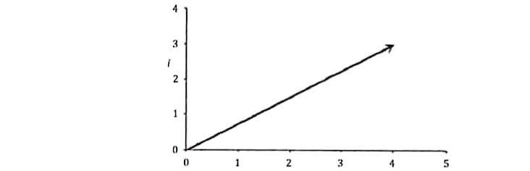

**Figure 31**: The vector 𝐼 = 4 + 3𝑖 in the complex plane.

A complex conjugate of a complex quantity must be defined to obtain its absolute value. The complex conjugate of 𝐼 = 4 + 3𝑖 is 𝐼∗ = 4 − 3𝑖, and the absolute value of 𝐼 is therefore |𝐼| =

=

=

=

|𝐼| = 5. (16) The angle 𝜃 between 𝐼 and the real axis is defined as tan 𝜃 = Im(𝐼)/Re(𝐼), where Im and Re refers to the imaginary and real components of 𝐼. Thus, the angle 𝜃 for the same number 4 + 3𝑖 above is

tan 𝜃 = $\frac{Im(I) }{Re(I) }$ = $\frac{3}{4}$ (17) **Complex Impedance**

In the complex plane, resistance is pictured on the real axis, inductive reactance is pictured in the +𝑖 direction on the imaginary axis, while the capacitive reactance is pictured in the −𝑖 direction on the imaginary axis. For example, we consider the current 𝐼 in the phasor circuit shown in **Figure 10** below.

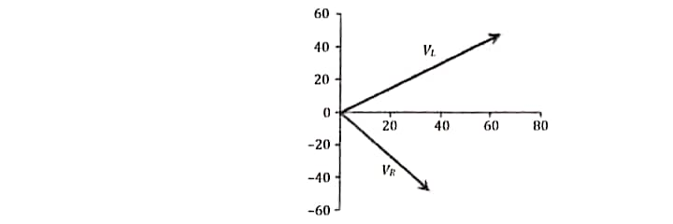

**Figure 32**: Example of a phasor circuit.

The total impedance of the circuit above is 𝑍 = 𝑅 + 𝑖𝑋𝐿 = 30 + 𝑖2𝜋*fL* = 30 + 39.96𝑖. The complex current is therefore

𝐼 = $\frac{V}{Z}$ = $\frac{100}{30+39.96i}=\frac{100}{30+39.96i}\frac{30-39.96i}{30-39.96i}$ = 1.2 − 1.6𝑖, (18) and the absolute value of the current is therefore |𝐼| = = 2 A.

To the draw the phasor diagram, we need to calculate the values of $V_{R}$ and 𝑉L, 𝑉R = 𝐼R = 36 − 48𝑖𝑖, (19)

𝑉L = 𝐼(𝑖𝑋L) = (1.2 − 1.6𝑖)(40𝑖) = 64 + 48𝑖𝑖. (20)

The values of 𝑉𝑉𝑅𝑅 and 𝑉𝑉𝐿𝐿 are visualised in the phasor diagram as shown in **Figure 11**.



**Figure 33**: Representation of 𝑉𝑅 and 𝑉𝐿 on the complex plane